The Issue
GridLAB-D is an open-source agent-based power system simulation tool developed by the US Department of Energy (DOE) and released in 2007. The tool enables detailed modeling of Distributed Energy Resource (DER) impacts on unbalanced three-phase power systems, as well as energy markets, building technologies, and other demand-side technologies that are becoming common in modern electricity systems. A barrier to widespread use of GridLAB-D is the existence of only a command line interface (CLI). Due to a higher level of training required, new users find the CLI very cumbersome and challenging. This results in increased training costs for new personnel and delayed adoption of the tool, which in turn limits the deployment of advanced grid technologies only GridLAB-D can model.
Developing a better user interface that is intuitive and more convenient to non-expert users would help make GridLAB-D more widely used and increase access to simulation and modeling results for advanced power system solutions by technology developers, researchers and public agencies. The user environment development, however, is difficult due to the following technical challenges:
- Complex information visualization: As a powerful simulation engine, GridLAB-D can assess impacts of DERs and controllable loads on distribution networks and substations from reliability, power quality and market economics perspectives. Effective visualization of these complex yet correlated systems is critical to understanding planning impacts and decision making.
- Scale-up capabilities for future needs: With the increasing penetration of renewables and DER, more operational data is available to serve as input to GridLAB-D planning models. It is necessary for the user interface to support flexible data loading architecture and provide scale-up capability to handle large volumes of data.
- Organic software growth: Professional users are uncertain about using open source software. A dedicated support team from a reliable vendor can facilitate user adoption and maximize return on investment in the tool. This team will assemble the basis of an eventual commercial-grade version of GridLAB-D that can support general-purpose open-source versions.
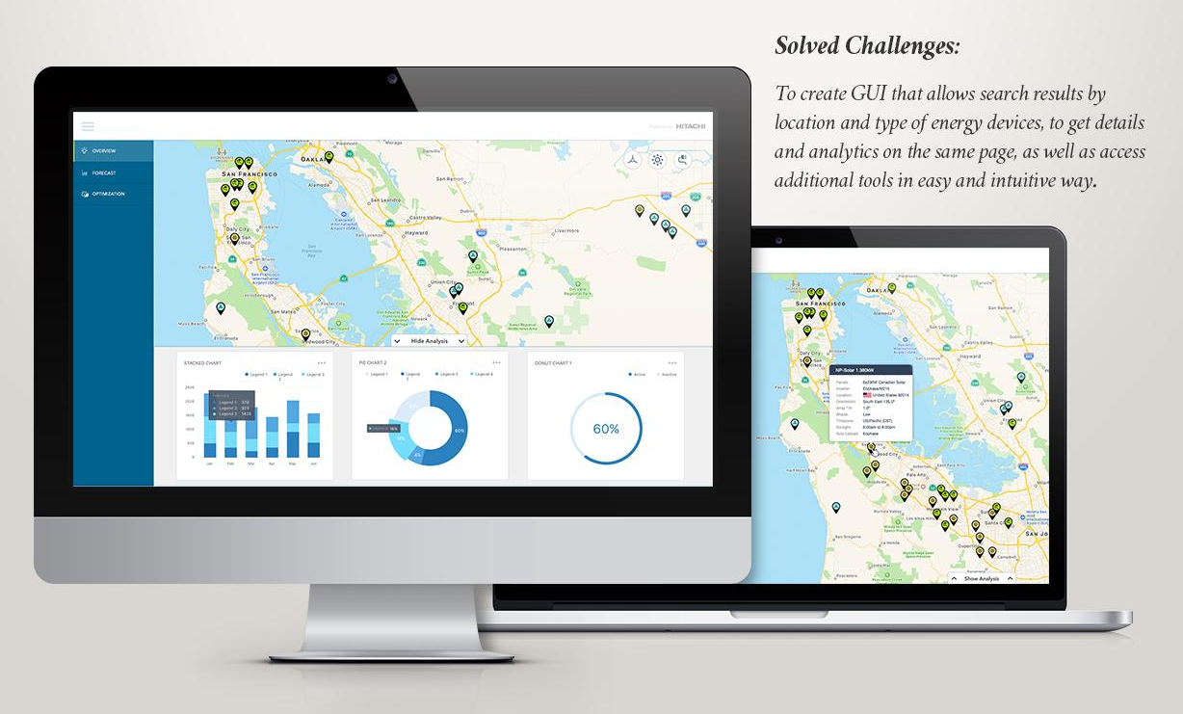
Project Description
GridLAB-D Open Workspace (GLOW) is a project to develop a high-end user interface for GridLAB-D that provides a more intuitive and user-friendly environment for researchers, planners, developers, and regulators involved in advanced electric grid technology deployment. GLOW will be a fully functional, freely available and widely supported open-source tool based on existing GridLAB-D technology and made available for a period of at least five years. The open-source tool augments and replaces the CLI for GridLAB-D. The interface will be developed to create input models and for execution and control of the simulations. GLOW will visualize complex information, be scalable for big data simulation, and be maintained by a reliable vendor to encourage widespread utility adoption. GLOW is expected to provide visualization for Gridlab-D, OpenFIDO and HiPAS.
GLOW integration with GridLAB-D will be directed by Hitachi America Ltd. (HAL), with technical support from Gridworks, National Grid, and two DOE national laboratories--SLAC National Accelerator Laboratory and Pacific Northwest National Laboratory--whose staff were the original developers of GridLAB-D. GridLAB-D source code revisions and upgrades will be implemented in a coordinated fashion with GLOW development. In addition, work may be coordinated with Groups 1-3 of GFO-17-305, so that GLOW can also provide visualization and integration of capabilities supporting those projects, if they use GridLAB-D as well. Along with formal release of GLOW, the project team will provide necessary documentation, training resources and online seminars to facilitate widespread adoption.
Anticipated Benefits for California
The state of California has identified increasing DER as an important element of its strategy to achieve its clean energy goals. Integration of DER into the distribution grid must be done in a manner that supports electricity system reliability without compromising personnel or public safety, or unreasonably increasing the cost of electricity to consumers. One barrier to this goal is evaluating the impacts of DER on the distribution grid, and making policy and investment decisions based on these results. Thus, one primary benefit of an improved user interface and visualization tool for GridLAB-D is support of increased modeling accuracy in decision-making surrounding DER technology adoption.
The GLOW project benefits California Investor Owned Utility (IOU) electricity ratepayers by supporting the goals of the CPUC Distribution Resources Plan (DRP) proceeding, as well as the broader goals of the state to support integration of DERs and planning for the grid of the future. An improved GridLAB-D user interface expands the number of users for power systems analysis tools, beyond just utilities, to include local communities, technology developers, researchers, public agencies and other organizations interested in assessing DER integration into the distribution grid.
Project Specifics
Contractor: Hitachi America LTD (HAL)
Partners: More Than Smart, SLAC National Accelerator Laboratory (SLAC), Pacific
Northwest National Laboratory, National Grid
Amount: $2,999,699
Co-funding: $1,255,060 from HAL, $80,000 in-kind from National Grid.
Term: June 2018 to December 2022

