Appendix A

PDR LSR 2.0

Product Description

Product Name: Load Shift Resource 2.0
Short Description: LSR 2.0, utilizing existing policy provisions for economically participating demand response utilizing the proxy demand resource, adds functionalities to the participation model allowing the resource to bid and be dispatched for both load consumption and load curtailment from behind the meter resources. The initial product will allow a PDR to access day-ahead and real-time energy markets for both load curtailment and load consumption capabilities through the use of two separate resource IDs. The proposal will facilitate the provision of “shift” services while maintaining a demand response policy principle that injection or export of BTM resources beyond the retail meter is not eligible for wholesale market compensation.
- Any PDR resource can participate if it has the capability to increase demand on the system in addition to curtailment capabilities
- Measurements based on demand response baseline calculations – current and those being implemented through ESDER 2 to calculate both curtailment and consumption.
- Retail rates still paid for consumption – wholesale energy a credit back towards the consumers.
- Load curtailment resource ID
  - Maintains RA capacity eligibility
  - Non-exporting rule applies
- Load consumption resource ID
  - Ineligible for RA capacity and ancillary services
  - Ability to bid a negative cost for load consumption energy services

Dispatch Method and Granularity

How are loads dispatched or instructed to shift: CAISO Day Ahead Market Awards or Real Time Market Dispatch based on economic bids submitted to these markets to either consume/charge or curtail/discharge.
- What is the time and spatial granularity?
  - Time step of dispatch signal: Fifteen Minute or Five Minute
  - Advance notice time to customer:
22.5 minute notification if Fifteen Minute dispatchable
2.5 minute notification if Five Minute dispatchable
Will permit future market enhancement of intertie bidding to provide additional notification times for RT market
  - Scale of geographic detail [circuit-feeder-PNode-SubLAP-DLAP-ISO]: SubLAP
  - Expected frequency of dispatch: N/A, frequency based on economic bid price
  - What is the triggering signal: Market price (DA Market and RT Market (FMM or RTD)
  - Is signal modified before dispatch? No

Organizational Roles

Describe responsibilities, relationship, and payments between the following parties.

Customer: Relationship with Demand Response Provider (Aggregator). No direct contact with CAISO (market or settlement activity)

Third Party / Aggregator: Demand Response Provider (Aggregator) becomes a market participant with the CAISO or contracts with a wholesale CAISO DRP to perform this function. Settlement of LSR 2.0 activities will be made to the Scheduling Coordinator (SC) of the DRP through CAISO settlement process (payment/charges).

Load Serving Entity (CCA or IOU or DA provider): N/A – LSE will continue to forecast and schedule customer load into the CAISO Markets separately from TN-PDR-LSR market activity. Load increase/decrease due to PDR-LSR market dispatches will impact LSE DLAP load settlement.

Distribution utility / service territory LSE (IOU): Utility and LSE maintains current role and responsibilities currently in place for demand response wholesale market participation, under the Proxy Demand Resource policy provisions, for those customers for which they have LSE/UDC responsibilities.

CAISO: Responsible for facilitating the registration, market participation, dispatching and settlement of the TN-PDR-LSR at a “resource level”. Settlements will be from the CAISO to the DRPs SC.

Regulator (CPUC or FERC): CAISO market participation is FERC jurisdictional. CPUC maintains jurisdiction on pre-market requirements for DRPs, as aggregator, to obtain customer meter data for use in market settlement. CPUC would be the entity to allow for additional incentives to participate in this product.

Participating load / device boundary and settlement

This set of criteria clarifies the options for participation by devices and/or premises-level load.

Is the product technology neutral: Yes

What is the smallest intended boundary for settlement: The LSR 2.0 resource

Sub-metering needs / value: No, could be considered if the CAISO/CPUC allow for metered devices to participate rather than full premises baseline participation. Today only full premises participation is permitted.

What is the settlement process (i.e., how is value estimated and performance verified):
- Aggregator role: SC metered entity, responsible for collecting required meter data and performing baseline calculations to develop a demand response energy measurement (DREM), following CAISO performance methodology, and submit the resulting settlement quality meter data to the CAISO.
- LSE role: Current responsibility for revenue quality meter data through Rule 24 processes.
- CAISO role: Process submitted DREM and perform market settlement of resource with DRPs SC.

How will performance be measured: Approved CAISO baseline methodology – will expand from current single baseline as ESDER 2 baselines are implemented, this will add a weather sensitive component. The SC or DRP will calculate the performance of the TN-PDR-LSR. Each performance methodology will be referenced as either “LSR-curtailment” or “LSR-consumption.” This is simplified without the need for determining typical usage as required for BTM storage devices.

What are the expected challenges: Baselines offer imperfect calculation of actual participation – but have been considered appropriate for the curtailment portion DR events historically and are utilized in PGE XPS pilot with reasonable success. Addition of ESDER 2 Baseline options may assist.
- Participant bidding/management of two separate resources. Is negative energy pricing alone enough incentive to encourage this behavior?
- What will impacts on demand charges be?
- If hourly bid intertie is used to provide a longer duration resource, the resource will be a price taker across the intervals, may result in some 5 minute period being higher than retail rates.

What are potential solutions:
- Continue to examine baseline best practices in a world of more frequent dispatches.
- Consider allowing separately metered devices to participate rather than full premise in aggregation.
- Examine additional incentive, capacity value for consumption portion of a resource, consider mechanisms to ensure customers never pay above retail rates (price taker across hourly interval) when directed to consume. Revenue could be available if we look to the value of avoided renewable curtailment.
- Look at demand charge structures. Coincident rather than non-coincident?

Contract Characteristics
Does a contract or tariff for this product exist: FERC jurisdiction tariff would need to be amended. CPUC jurisdiction tariff could be needed for additional incentives. Capacity contract would need to be enabled at CPUC for payment.

If a contract does not exist, complete the following
- Contract/tariff duration: PDR LSR Tariff filing will occur Q3 2019 and remain in perpetuity unless further amended. Expected that amendment would be needed to expand to a TN-PDR-LSR, ESDER 4 as avenue.
- Time/Location of response specified: no timeline yet for TN-PRD-LSR – would this need a CAISO process – ESDER 4?
- Reference price or market-based: Market-based.

Product Evaluation
The goal of this section is to elaborate on the characteristics of the product and its expected implementation for a set of evaluation criteria that can aid judgement on the merits / value.

Market Integration

Describe how this product is linked with the CAISO energy market.
Is it intended to be directly dispatchable by CAISO: Yes
If yes, does it fit into an existing market model: Yes, with modifications
What changes to policy or practice are required: Included in Proxy Demand Resource product capability with modifications.

Is the product dispatched outside of the CAISO market, but reasonably considered “market integrated”: No

Grid Needs Match
What grid needs does this product solve: TBD

Does this product enable the resource to also provide other services (i.e., dual participation)? What additional services does it enable: Yes, can accommodate non-24x7 market participation allowing for multi-use application (customer/distribution services).

How do the dispatch details (described previously in product description section) inform its value to the grid? For example, describe the response time, notification, geographic granularity, etc. and how this supports grid needs: Participation model for provision of energy service for provision of curtailment and consumption. Provision of resource adequacy (MOO) and ancillary service for provision of curtailment only. Provision of services economically optimized with consideration of Transmission system needs when participating in the markets. Requires aggregations to be within a Sub-Lap. Requires a fifteen minute or 5 minute response (notification described above). Would expand to use intertie bidding for RT proposed for DR resources.

For each of the grid needs identified in the list above, describe:
- How can the magnitude of value be estimated: Performance based/market priced.
- Is there an existing revenue mechanism accessible:
- Yes, DA/RT markets, DRAM (for curtailment only)
- Additional revenue could be considered to encourage utilization
- What Is the minimum kW / kWh size: 100 kW
- What is the maximum kW / kWh size: N/A

Is the product delivering an incremental service: Yes
How is the incremental value determined: Determined through a performance evaluation methodology that adjust for typical usage to determine it incremental service.

Customer Experience
What is the anticipated ability of customers to respond to the product in the time frame and geographical time space suggested: Ability is analogous to current PDR customer experiences in meeting participation requirements and dispatch instructions.
Are there particular customer co-benefits related to participating: Benefit from offering consumption capabilities from aggregations already participating in the CAISO markets. Retail rate arbitrage - ability to offset retail rate impact.
What are the likely use cases where participant economic benefit coincides with grid needs (e.g. scheduling an extra production shift during low price periods): Provision of consumption services during periods of oversupply (negative pricing) with ability to provide curtailment during periods of ramping to and from those periods.
What are the challenges and opportunities for participation across customer classes (residential, small commercial, large commercial, industrial, agriculture, municipal, etc.): Challenges analogous to current PDR customer experiences in meeting participation requirements and dispatch instructions.
Can current DR-providing customers participate without significant control technology upgrades: Analogous to current PDR control technologies needed for curtailment dispatch instructions. (removes need for BTM storage)

Potential Ratepayer Costs
Grid IT Systems
Describe how the product is compatible with existing utility IT/metering/billing systems.

Does retail meter data granularity meet product needs: Yes
Do overall utility IT systems meet product needs: Yes

If no to any above, what changes may be warranted: N/A
What are potential challenges/costs of those changes: N/A
What are potential spillover benefits of those changes: N/A

Other Ratepayer Costs
Incentives: Requires review if additional incentives beyond energy applied. ON the benefits side avoided renewable curtailment.
Lost Revenues: N/A
Other: N/A

Greenhouse Gas

What are the expected greenhouse gas emissions impacts from implementing the product: Unable to determine, should not add to emissions since over supply conditions resulting in negative market prices are in periods of high renewable energy availability. Avoids renewable curtailment.

Appendix B

Critical Consumption Period

Product Description
Product Name: Critical Consumption Product (to be piloted in a Critical Consumption Period Pilot)
Short Description: The Critical Consumption Product is a load increase demand response product that can be considered to be integrated into the wholesale market because it is informed by the market. The incremental load increase is triggered directly by negative wholesale Day Ahead nodal market prices and paid at the real time nodal wholesale market prices (i.e., an average of real-time intervals in a 15-minute retail interval). The increases in solar (and to a lesser extent wind) generation correspond to negative or low wholesale electricity prices. The load increase product could possibly be paired with a load drop and thus be a load shift product, depending on notification times and stakeholder willingness to support this approach. However, there would not be an exact 1:1 load shift requirement.
The load increase (Critical Consumption) would occur during Critical Consumption Periods, which are intended to occur during periods of renewables curtailment due to low net load (as represented by the belly of the duck in the infamous CAISO duck curve). Renewables curtailment has increased from 187 GWh in 2015, to 308 GWh in 2016, to over 404 GWh in 2017. The load increase would be incented by having the incremental load “pay” a negative real-time wholesale market nodal price for energy (and non-energy components of the retail rate), and *possibly* earn a monthly participation incentive. There is a link between negative day-ahead prices and likelihood of curtailment of renewable resources in real time. This proposal seeks to (1) raise the belly of the duck and avoid renewable curtailment, and (2) enable California’s large, energy intensive power customers to take advantage of their investment in renewable resources by accessing excess, low-cost renewable energy to power manufacturing and industry. Both of these would help the state meet GHG emissions reductions goals. It would also address the current gap in DR Programs due to the termination of the Demand Bidding Program.
Previously, customers were able to dual participate in the Base Interruptible Program (a capacity program) and the Demand Bidding Program (an energy program), but the Demand Bidding Program was terminated at the end of 2016 for PG&E and the end of 2017 for SCE. No replacement energy program has been offered since that would enable customers to continue dual participation in an energy program and BIP. This resulted in a gap in DR Programs. Since the Critical Consumption Period is an energy program, it should enable industrial customers to dual participate in both reliability (the Base Interruptible Program for capacity) and economic energy (Critical Consumption Period Pilot) demand response, per dual participation rules. The question has been raised whether the current dual participation rules should apply to demand response that increases load. The goal of dual participation rules is to avoid double payment for the same change in load. Here, several of the same safeguards that avoided double payment for dual participation BIP and DBP apply: one is capacity and the other is energy; one is day of and the other is day ahead; if, in the unlikely event the events overlap, the BIP event would take priority, with no payment for the CCP event. Moreover, here, the BIP change in load is a reduction and the CCP change in load is an increase; CLECA believes that the goal of the dual participation rules, to avoid double payment, would be met. This question, however, may need to be explored further, to ensure all stakeholder and staff questions are answered and to eliminate double payment concerns.
Dispatch Method and Granularity
How are loads dispatched or instructed to shift:
- Triggers: Load is instructed to shift by an IOU/LSE communication based on the actual Day Ahead market run. When the actual Day Ahead market price is negative, a Critical Consumption Period may be triggered.
  - Based on prior years, it is expected (although not guaranteed) that most Critical Consumption Periods of negative pricing will occur during the Spring months, and are more likely on weekend days; 2017 CAISO Real time 15 minute pricing data on periods of low or negative prices suggest there could be more than 12-15 events, but there have been fewer periods of negative pricing so far in 2018.
  - While there have been fewer periods of negative pricing, CAISO data shows that renewable curtailment has continued, both at the local and system level.
- Duration: The Critical Consumption Period can have varying durations, from 1 to 6 hours, with the customer able to select the duration range.
- Quantity: The customers’ Critical Consumption (the increased consumption amount) based upon different prices would be nominated on a monthly basis, and the customer may opt to have different Critical Consumption amounts for weekends vs. weekday amounts. When the IOU/LSE communicates an event, the customer can opt to participate in the event with an increased consumption amount.

- What is the time and spatial granularity?
  - Time step of dispatch signal: Day-ahead nodal price is the dispatch signal;
  - in the real-time market, customers are exposed to Real Time 15-minute pricing increments; customer to select their event duration range, with the actual event duration set by the market, in 1-hour increments.
  - Advance notice time to customer: Day ahead, by 5 pm at the latest.
  - Scale of geographic detail [circuit-feeder-PNode-SubLAP-DLAP-ISO]: Nodal
  - Expected frequency of dispatch: No limit; available year-round, but most CCPs
are expected to occur in the winter and spring seasons (shoulder months); CLECA suggests a minimum range of 12-15 Critical Consumption Periods over the course of the year; this range could be increased by the LSE; participation is voluntary and there is no penalty for not performing. If a customer cannot respond with a load increase during an event, the event performance would be the same as the baseline (effectively an opt-out, but it would not have to be tracked by the administrator). In the unlikely circumstance of a Critical Consumption Period simultaneous with a DR Reliability Program (ie BIP) call, the reliability event would take priority and the CCP event will not count toward the minimum number of events.
  - What is the triggering signal: Negative Day Ahead, Market price as indicative of likely renewable curtailment.
  - Is signal modified before dispatch: No

Organizational roles

Describe responsibilities, relationship, and payments between the following parties.

Customer: Customer provides the energy product and “pays” the wholesale energy price for the incremental Critical Consumption during the Critical Consumption Period.
Third Party / Aggregator: Could aggregate customers to participate in the utility/LSE program.
Load Serving Entity (CCA or IOU or DA provider): Runs or participates in an IOU pilot program, communicates the triggered events and passes through the savings from the wholesale market

Distribution utility / service territory LSE (IOU): Runs the pilot program and settles the activities similar to PG&E’s XSP settlements, may rely on an administrator (eg, Olivine, as in XSP), paying the customer for participation

CAISO: No specific role, other than timely closing of DA market run with market run results announced by 2 pm

Regulator (CPUC or FERC): Pilot would be CPUC-jurisdictional and administered by CPUC-jurisdictional entities and overseen by the CPUC, as with other CPUC-jurisdictional DR Pilots (e.g., DRAM, SSP, XSP).

Participating load / device boundary and settlement

This set of criteria clarifies the options for participation by devices and/or premises-level load.

Is the product technology neutral: Yes

What is the smallest intended boundary for settlement: Premises; could be an aggregation

Sub-metering needs / value: No

What is the settlement process (i.e., how is value estimated and performance verified):
- Aggregator role: if participating, authorize MDMA to provide meter data and baseline calculations to Scheduling Coordinator and pilot (LSE) administrator
- LSE role: have SC/pilot administrator collect meter data and perform baseline calculation for non-aggregated customers.
- CAISO role: None

How will performance be measured: As in PG&E’s XSP, performance would be measured by subtracting the baseline load from the event load. A 10-in-10 wholesale baseline methodology would be used to determine the baseline load and estimate the average load from the 10 similar days to get the baseline load.

What are the expected challenges: The primary challenge is whether the negative energy wholesale market price would suffice to incent the increase in consumption, due to the impacts on the retail maximum demand charge. The main impediment is the non-coincident facilities related demand charge, which for transmission is set by the Federal Energy Regulatory Commission, and passed through by the CPUC. For E-20T customers, PG&E’s maximum demand charge is $8.01/kW.

Additional challenges include parsing and including the Power Charge Indifference Adjustment; how the retail rate signals from current time-of-use periods and the to-be implemented time-of-use periods will align, and how the pilot would be funded.
What are potential solutions: Sufficiently negative energy prices could overcome or help mitigate the maximum demand charge. Flexibility around the CPUC-jurisdictional, generation-related coincident demand charge could also help. Consideration could be given to seeking FERC approval of a different calculation of cost basis and rate design for the maximum demand charge, as the transmission system is summer peaking and it would be highly unlikely that shoulder-month Critical Consumption Periods would lead to increased marginal transmission costs; this different calculation of cost basis and rate design could be time-limited and subject to subsequent review.
For the funding challenge, utilities could seek approval for fund-shifting, or this proposal could be worked into the XSP Pilot for PG&E; a cap on the number of participants, or limiting the participants to large power rate schedules could help address funding constraints.

Contract Characteristics:
Does a contract or tariff for this product exist: TBD

If a contract does not exist, complete the following
- Contract/tariff duration: TBD
- Time/Location of response specified: TBD
- Reference price or market-based: TBD

Product Evaluation
The goal of this section is to elaborate on the characteristics of the product and its expected implementation for a set of evaluation criteria that can aid judgement on the merits / value.

Market integration

Describe how this product is linked with the CAISO energy market.
Is it intended to be directly dispatchable by CAISO: No
If yes, does it fit into an existing market model: N/A
What changes to policy or practice are required: N/A

Is the product dispatched outside of the CAISO market, but reasonably considered “market integrated”: Yes; the customer’s response is directly linked to the CAISO market price, so this could be considered to be market integrated, as the response is triggered by the market price signal.

Grid needs match
What grid needs does this product solve: It avoids renewable curtailment. To maintain a balanced system any increase in load has to be met with increased generation. If curtailment is happening, then any increase in load should likely also reduce renewable curtailment. While this issue is complex, it is hoped that if this consumption product is called after the day-ahead market run and LSE notifies the CAISO, then if the CAISO could incorporate the information into their real-time load forecast that would inform the real-time unit commitment and dispatch models. Since load would be higher than the day-ahead forecast, then there should be less renewable curtailment. The role of the CAISO is important as the load is not bid into the CAISO’s real-time market. (Load is only bid in day-ahead.) Moreover, the CAISO real-time market is continually learning, and adjusting its forecasts in real time; thus, when there is more or less load than forecast in an interval, the load-supply balance is re-balanced in a subsequent interval. Accordingly, while the critical consumption does not get a market award, it is possible for it to influence the real-time market.

Does this product enable the resource to also provide other services (i.e., dual participation)? What additional services does it enable: It should enable dual participation by customers.

How do the dispatch details (described previously in product description section) inform its value to the grid? For example, describe the response time, notification, geographic granularity, etc. and how this supports grid needs: By being triggered on a day-ahead timeframe during expected periods of renewables curtailment based on Day-Ahead prices and at the granular nodal level, the product can support the grid need to avoid renewable curtailment.
For each of the grid needs identified in the list above, describe:
- How can the magnitude of value be estimated: Currently, the negative market price; in the future, there might be a way to access the value provided by avoiding renewables curtailment, but that doesn’t exist yet.
- Is there an existing revenue mechanism accessible: Yes, for the negative market price of energy.
- What Is the minimum kW / kWh size: 100 kW
- What is the maximum kW / kWh size: N/A

Is the product delivering an incremental service: Yes, by avoiding renewable curtailment.
How is the incremental value determined: No methodology currently beyond negative wholesale energy market price.

Customer Experience

THE PILOT MUST ALLOW DUAL PARTICIPATION WITH BIP. No need for capacity value payment if can dual participate with BIP (capacity program) and pilot (energy program)

What is the anticipated ability of customers to respond to the product in the time frame and geographical time space suggested: It depends on the economic incentive.
Are there particular customer co-benefits related to participating: Dual participation should increase the RDRR headroom under the cap, because the load that participates in an economic (energy) program while also participating in a reliability (capacity) program does not count towards the RDRR cap; accessing lower energy costs, should enables increased in-state energy-intensive manufacturing, which helps the state meet its climate goals by avoiding leakage.
What are the likely use cases where participant economic benefit coincides with grid needs (e.g. scheduling an extra production shift during low price periods): Likely use cases are where participant economic benefit coincides with grid needs: increased manufacturing production during low price periods.
What are the challenges and opportunities for participation across customer classes (residential, small commercial, large commercial, industrial, agriculture, municipal, etc.): CLECA suggests limiting this to large power customers: PG&E E-19T, E-20T; SCE TOU-8-Sub as they have the meter data granularity and this would avoid issues with distribution demand charges.
Can current DR-providing customers participate without significant control technology upgrades: Yes, large C&I customers could.

Potential Ratepayer Costs
Grid IT Systems
Describe how the product is compatible with existing utility IT/metering/billing systems.

Does retail meter data granularity meet product needs: For large C&I, yes
Do overall utility IT systems meet product needs: Not yet; expect a “work-around” (like PG&E’s use of Olivine for XSP).

If no to any above, what changes may be warranted: Utility billing system changes to enable real-time pricing; for this proposal, payment would be made to the customer outside the utility billing system.
What are potential challenges/costs of those changes: Utility billing system changes are significant.
What are potential spillover benefits of those changes: More dynamic and responsive load generally.

Other Ratepayer Costs
Incentives:
Lost Revenues:
Other:

Greenhouse Gas
What are the expected greenhouse gas emissions impacts from implementing the product: This is difficult to estimate and is subject to many factors and assumptions. On the generation side since less renewables are curtailed, there should be no increased generation emissions. On the customer side, it is possible that there may be additional emissions from the manufacturing process. However, if load is shifted from a time period when gas is on the margin to period when renewable is on the margin, then the overall emissions would be reduced.

Appendix C

MIDAS

Product Description

Product Name: Market Informed Demand Automation Services (MIDAS)
Short Description: MIDAS encompasses a variety of potential demand automation services deployed by vendors utilizing either a market or grid state informed signal that is acted upon by a controller connected to an end-use. Example end-uses that can respond to these continuously streaming signals are: air conditioning compressors via a direct load control switch or a smart-thermostat, batteries via a smart-charging device, refrigerators via a smart-plug or OEM smart-controller, water heaters via add-on or OEM smart-controller, lighting via a smart-controller, pool pumps via smart-controllers, other plug loads via smart-plugs. Time granularity of market or grid state informed signals can be as low as 5 minutes but can be forecast for planning purposes for as long as 30-days. Locational granularity of market or grid state informed signals can be as low as a CAISO pricing node or a distribution feeder but can be aggregated or adjusted to meet a variety of use cases. Subscription based model wherein customer pays vendor for providing signal and/or automation devices and control API in exchange for vendor providing economic and/or environmental benefits of equal or greater value to the customer.

Dispatch Method and Granularity

How are loads dispatched or instructed to shift: Under MIDAS Loads are shifted into lower price or lower emission periods based on an API that takes as inputs the market or grid state informed signal, customer preferences and other end-use operating constraints. MIDAS bundles the signal/preferences/constraints which are processed by a set of decision algorithms and relayed (usually via WiFi but could be via Zigby or cellular signal) to a controller that is attached to the end-use load.
- What is the time and spatial granularity?
  - Time step of dispatch signal: Five Minute
  - Advance notice time to customer: Customized to meet customer’s preferences
  - Scale of geographic detail [circuit-feeder-PNode-SubLAP-DLAP-ISO]: Circuit-feeder
  - Expected frequency of dispatch: High frequency depending on customer preferences and end-use operating characteristics.
  - What is the triggering signal: Streamed via open-ADR and can be informed by market prices or by other grid state indicators such as air emissions. Signal can be modified along the connection path for example an energy market price signal can be modified at the distribution level-based feeder of local transmission level congestion.
  - Is signal modified before dispatch? No

Organizational Roles

Describe responsibilities, relationship, and payments between the following parties.

Customer: The customer is responsible for providing the end-use that can be controlled and for providing a set of preferences regarding how the device is controlled. The customer may pay a small subscription payment for the technology and services provided by the DRP.

Third Party / Aggregator: The DRP provides or purchases the signal and provides or purchases the API working with the signal providers and the controller OEMs. The DRP develops the “program” offerings and recruits and services the customers.

Load Serving Entity (CCA or IOU or DA provider): LSEs can play the role of DRP or they can fund a third-party DRP or they can be passive. Regardless of the role played by the LSE, the LSE should be aware of the MIDAS “program” and should include the expected impacts of the MIDAS program in their planning and operational forecasts.

Distribution utility / service territory LSE (IOU): The UDC can play various roles. It could inform/modify the signal based on local capacity constraints. It could institute the program directly in an area for local needs. etc.

CAISO: The CAISO is essential in providing the real time price or grid state indicators at the right level of time and locational granularity that is appropriate.

Regulator (CPUC or FERC):

Participating load / device boundary and settlement

This set of criteria clarifies the options for participation by devices and/or premises-level load.

Is the product technology neutral: Yes

What is the smallest intended boundary for settlement: The product is not market integrated but rather market informed. If the product was market integrated, it would likely have to be integrated at the “fleet” level. It should generally be the case that an aggregation of 5,000-10,00 end-use devices utilizing MIDAS would provide a reliable enough resource for market integration through a pathway identified by this working group.

Sub-metering needs / value: The product is not market integrated so sub-metering should not be needed. MIDAS relies on many small and distributed actions taken at the grid edge to collectively provide services that provide value to customers and the grid.

What is the settlement process (i.e., how is value estimated and performance verified): Since this is a market informed but not a market integrated product there no formal “settlement” process. The retail customer is compensated by either bill reduction or by emissions reductions. There could be additional sources of revenue available including revenues from CAISO markets if the product becomes market integrated at some point or revenues from Government Agencies distribution funding for emissions reductions such as EPA/CARB/Air Quality Districts or by NGOs that are focused on emissions reductions.

How will performance be measured: Performance is measure by peak-power pricing or emissions that consumers avoid in the sense that the more load shifting that is done, a customer will save more money or emissions. Performance can be measured in overall cost and emissions savings.
Although there is not a base-line per se, the value is real in that it delivers immediate relief to real-time grid conditions, regardless of any prescribed formula. One simple metric for performance from a cost savings standpoint is that a 3rd party control system would need to load shift for a value higher than the monthly fee they subscribe to keep a customer happy. At an example fee of $10/month, the 3rd party would need to load shift away from 10kW of $1,000 MWh power. From an emissions standpoint, performance can be measured by the quantity of low or no-emissions electricity that is consumed.

What are the expected challenges: Consumers would need to have smart devices within their home. Consumers would also need to trust 3rd parties to optimize on their behalf.

What are potential solutions: Recent stats show that approximately 13% of households have smart thermostats already installed, with that amount increasing rapidly. Costs are declining significantly in wifi-connected devices. A benchmark for the public gaining trust of 3rd parties to optimize on their behalf are financial investment “robo-advisors”. Wealthfront and Betterment are examples of this. Consumers have adopted these types of Artificial Intelligence platforms to optimize investments in a way that is very analogous to what a 3rd party would provide for energy management optimization.

Contract Characteristics
Does a contract or tariff for this product exist:

If a contract does not exist, complete the following
- Contract/tariff duration:
- Time/Location of response specified:
- Reference price or market-based:

Product Evaluation
The goal of this section is to elaborate on the characteristics of the product and its expected implementation for a set of evaluation criteria that can aid judgement on the merits / value.

Market Integration

Describe how this product is linked with the CAISO energy market.

The product dispatched outside of the CAISO market, but reasonably considered “market integrated” because, at scale and due to automation, the responses of the end-uses subscribed under these programs are highly predictable and can be picked up by the LSE and CAISO short-term load forecasting models that are relied upon for market awards as well as longer-term forecasts that are used to determine RA obligations and for T&D infrastructure planning.
Is it intended to be directly dispatchable by CAISO:
If yes, does it fit into an existing market model:
What changes to policy or practice are required:

Is the product dispatched outside of the CAISO market, but reasonably considered “market integrated”:

Grid Needs Match
What grid needs does this product solve: This non-market integrated product can provide all the same grid services as the PDR and PDR-LS products. In addition the product could be tailored to provide local transmission and distribution services and to provide local or system air emissions reductions.

Does this product enable the resource to also provide other services (i.e., dual participation)? What additional services does it enable:

How do the dispatch details (described previously in product description section) inform its value to the grid? For example, describe the response time, notification, geographic granularity, etc. and how this supports grid needs:

For each of the grid needs identified in the list above, describe:
- How can the magnitude of value be estimated:
- Is there an existing revenue mechanism accessible:
- What Is the minimum kW / kWh size:
- What is the maximum kW / kWh size:

Is the product delivering an incremental service:
How is the incremental value determined:

Customer Experience
What is the anticipated ability of customers to respond to the product in the time frame and geographical time space suggested: Since the product is fully automated, the 3rd party responds on behalf of the customer. This ensures higher and more effective participation.

Are there particular customer co-benefits related to participating: Every $1,000 MWh avoided is significant savings to the participating customer and this benefit is shared with the broader rate base since their costs incurred are lower.
What are the likely use cases where participant economic benefit coincides with grid needs (e.g. scheduling an extra production shift during low price periods): Typically, the load is being automatically shifted away from dirty or expensive times to clean or cheap times of the day, absorbing solar energy that would have otherwise been curtailed and/or providing price signals to encourage more solar energy to be developed.

What are the challenges and opportunities for participation across customer classes (residential, small commercial, large commercial, industrial, agriculture, municipal, etc.): Residential will require marketing effort to raise awareness of this tool that can automatically save cost or emissions on behalf of the client. Large commercial customers often already have access to sophisticated tools similar to this.

Can current DR-providing customers participate without significant control technology upgrades:

Potential Ratepayer Costs
Grid IT Systems
Describe how the product is compatible with existing utility IT/metering/billing systems.

Does retail meter data granularity meet product needs:
Do overall utility IT systems meet product needs:

If no to any above, what changes may be warranted:
What are potential challenges/costs of those changes:
What are potential spillover benefits of those changes:

Other Ratepayer Costs
Incentives:
Lost Revenues:
Other:

Greenhouse Gas
What are the expected greenhouse gas emissions impacts from implementing the product: There would be significant greenhouse gas impacts. Aligning consumption to actual grid carbon intensity is much more impactful than an accounting-based system of RECs. This type of product could make demand truly flexible in a way that it follows price and carbon signals, since solar and wind are inflexible generation resources.

Appendix D

Pay For Load Shape

Product Description
Product Name: “Pay for a Load Shape” (P4LS)
Short Description: Is there a way to design a program to incentivize the anti-duck curve without asking customers to respond to dynamic prices or participate in energy markets? The “Pay for a Load Shape” concept (“PLS”) describes a range of approaches that could be used to provide simple, clear, and cost-effective target load shapes that are updated periodically based on evolving conditions on the grid. Customers who are participating in the program would modify their loads, either at the site-level or in aggregate, and be compensated for the response. The value of incentives could be related to the reductions in the cost of serving loads that meet or approach the target, and could include contributions from energy market savings and reduced costs for capacity (generation, transmission, distribution). The geographic granularity of the load shapes, how frequently they are updated, and whether different targets are appropriate for different customers, are critical decisions for product design.
Dispatch Method and Granularity

How are loads dispatched or instructed to shift.
- What is the time and spatial granularity?
  - Time step of dispatch signal: Hourly time steps, Weekday-Weekend Day
  - Advance notice time to customer: 1-month advance notice, persistent for 1-3 months
  - Scale of geographic detail [circuit-feeder-PNode-SubLAP-DLAP-ISO]: circuit-feeder-PNode-SubLAP-DLAP-ISO
  - Expected frequency of dispatch: Seasonal dispatch; persistent for 1-3 months
  - What is the triggering signal: The main source of the systemwide or SubLAP load shape would be the typical daily net load for the 1-3 month planning period. This could include information about expected loads, expected market prices (or cost of energy to serve load), expected marginal GHG emissions, and/or expected local air pollutant emissions. These system-scale shapes could be augmented with information about specific local constraints: distributed generation, distribution system constraints, and other factors that may influence the target load shape for specific pricing nodes, feeders, or circuits.
  - Is signal modified before dispatch? Yes. The target load shape is an aggregate of the information above. The specifics of aggregation is subject to more detailed product design / pilots.
One (but not the only possible) concept for how the signal could look, for system-level targets, is shown in the figures below. The first shows the CAISO net load for 2017, and below that, prices for the same year based on a synthesis available online from LGC Consulting.

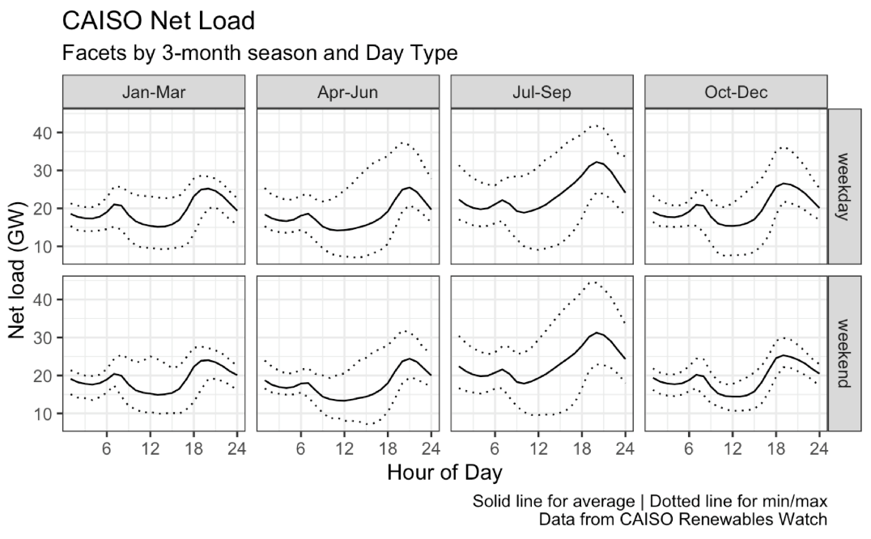
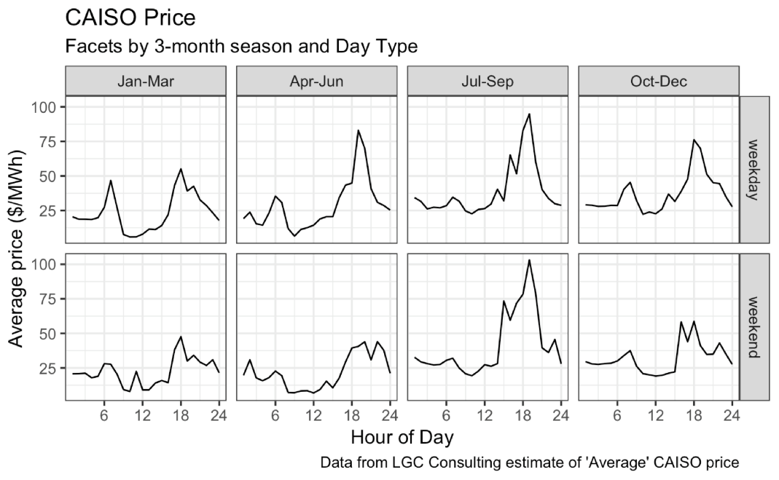

On possible simplified concept for the construction of a target load shape is the inverse of the average net load in each season and day type. In this version the target load shape is “re-zeroed” so that the hourly values represent the fraction of variable load consumed in each hour. The magnitude of the target for a specific site could be matched to the site-level kWh consumption, accounting for inflexible base load and flexible variable load. Another possible construction of the target load curve could be based on the expected prices. The version below is based on a publicly available aggregation of “average” CAISO prices (from LGC Consulting). In practice, a less noisy and more uncertain price forecast could be more appropriate. These plots are for illustrative purposes.

The plot shows that the “anti-duck” net load is a reasonable predictor of average prices and may be a sufficient target, or the basis for a target. Additional features could be added to the target load shape as well to induce other behaviors in customers.

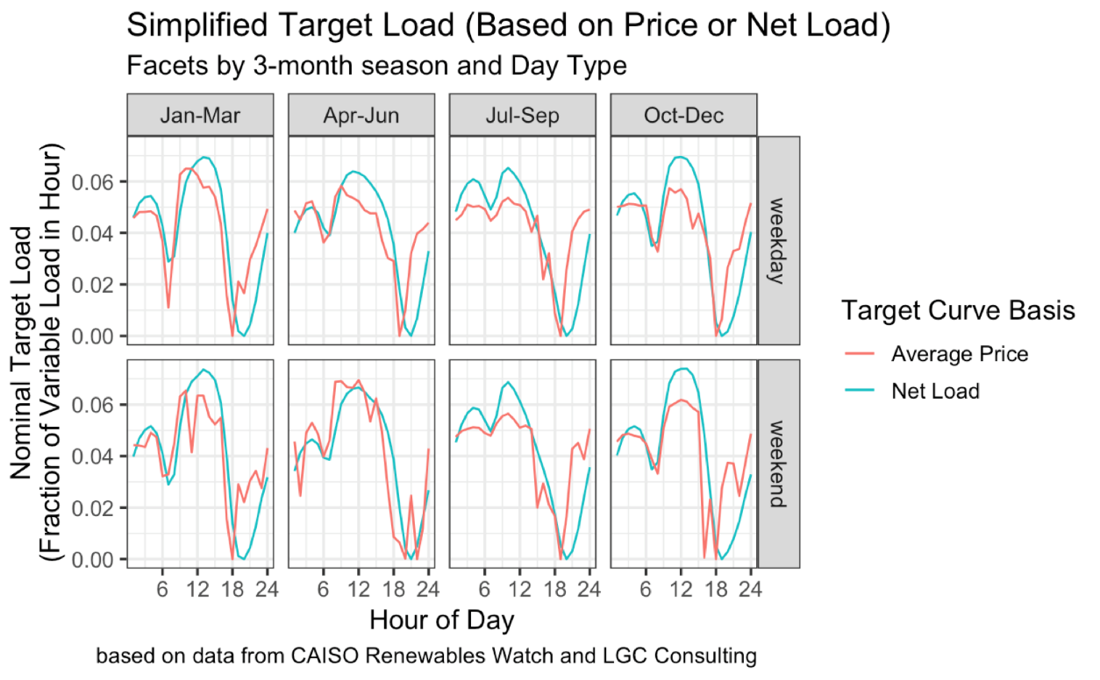

Organizational Roles

Describe responsibilities, relationship, and payments between the following parties.

Customer: Participate in programs directly or through aggregator. Invest in enabling technology. Receive signals from aggregator, LSE, and/or Distribution Utility. Receive incentives and or performance payments (source depends on the participation model).
Third Party / Aggregator: Support deployment and aggregate sites for participation. Invest in enabling technology on behalf of customers. Send operational signals to customers in network. Receive payments from LSE / Distribution system utility for performance of customers and aggregations of customers. Pass through customer incentives and payments, according to retail product design of Third Party

Load Serving Entity (CCA or IOU or DA provider): Define SubLAP or DLAP level target load shape that minimizes cost of service. Publish target load shape (if appropriate)

Distribution utility / service territory LSE (IOU): Refine target based on distribution system constraints and modified target needs. Provide incentives for modified targets related to avoided cost of distribution upgrades. Provide AMI meter data access to support settlement. Participate in publication of target load shapes and ensuring cybersecurity, if they are modified for local constraints.
CAISO: Support forecasts of net load / price and market data access. Support program evaluation and valuation of response with CAISO analysis and models. Incorporate expected responses to program into transmission planning process?

Regulator (CPUC or FERC): Provide regulatory oversight for target load shape definition, publication, and verification processes? Editorial Note: Defining the target load shape for the system-scale (before any local modifications) would weigh costs, pollution, and customer experience. How to balance public oversight need with the need for maintaining nimble response to changes in grid needs? How will non-IOU LSE’s be treated in any regulatory oversight?

Participating load / device boundary and settlement

This set of criteria clarifies the options for participation by devices and/or premises-level load.

Is the product technology neutral: Yes

What is the smallest intended boundary for settlement: Aggregation or Premises. It could be possible to structure for end-use also (see below).

Sub-metering needs / value: Possible value, if specific loads are given a target shape (e.g., EV charging) that is different from system-level. Not required.

What is the settlement process (i.e., how is value estimated and performance verified):
- Aggregator role: Estimate performance compared to target load shape for customers.
- LSE role: Define the framework for estimating the performance of customers compared to the target load shape, and the value of payments to be provided. Provide payments to customers and/or aggregators for performance compared to the target load shape, based on the framework. Verify performance compared to target load shape with AMI data.
- CAISO role: Support LSE with good quality data to support forecasts in net load, prices, etc

How will performance be measured: The customer load is compared to the target, and a pre-defined formula is used to score the accuracy / response. The scores are used to allocate incentives and/or performance payments.
NOTE: This process could be combined with pay-for-performance EE programs as appropriate.
Some examples of the kinds of metrics useful for scores are:
1) Mean absolute difference between the target load shape and the average customer load shape;
2) Correlation between the target load shape and the average customer load
3) Weighted average cost of serving the customer load based on “LNBA-style” estimates associated with or published alongside the target load shape.
Below is an illustrative example of the relationship between a performance metric and the cost of serving load for 24 grocery stores (based on 2012 EnerNOC data release of hourly data for R&D purposes). In this example, the nominal target load shape for the sites is the inverse of the average market price. For each site, a specific target is established so that both of the following conditions are true: 1) The “base load” for the site --- the minimum of the average load shape --- is not included in the variable portion of the target. 2) The sum total energy consumption of the target load shape is equal to the energy consumption of the site.
The actual average loads at two facilities, and the target loads based on the algorithm above, are shown in the two plots below. These are labeled as “good” and “poor” matches between the actual load the target. In an operational deployment of PLS, customers and/or aggregators would attempt to modify the average actual load to approach the target load shape.

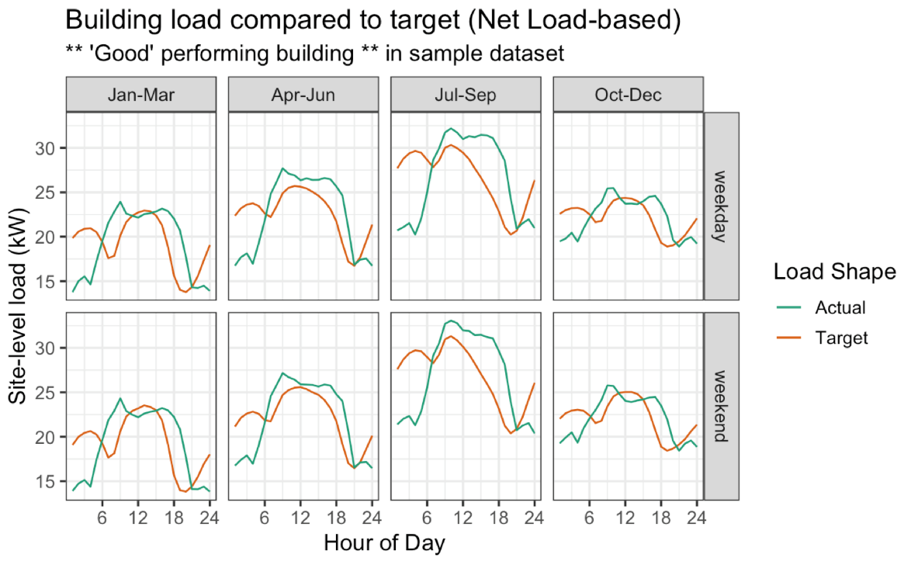

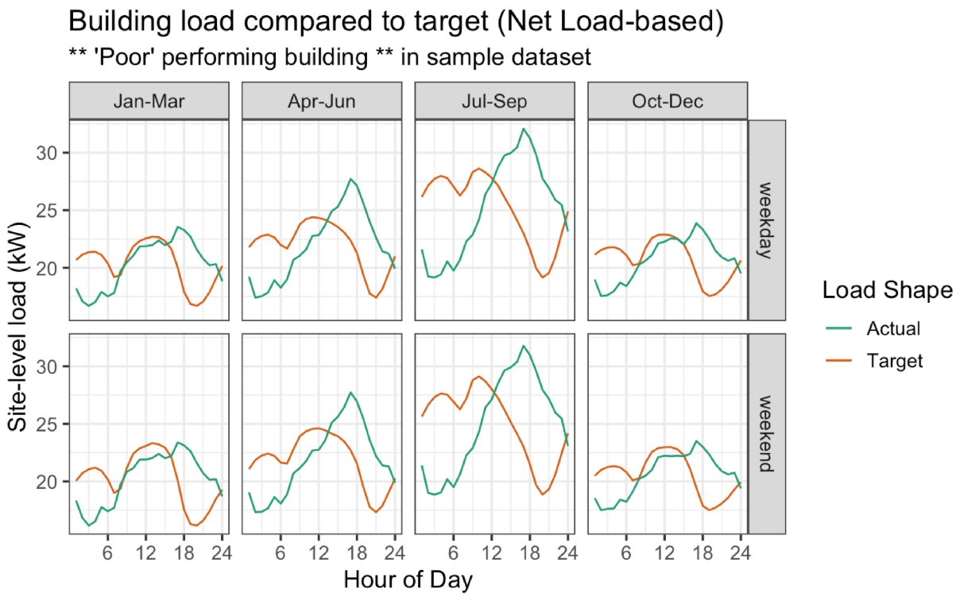

One possible metric for scoring the performance of buildings compared to the target load shape is “correlation” (the statistical correlation coefficient between the average building load and the target load). As the correlation between the actual load and target gets higher, there should be lower cost associated with procuring energy to serve the customer loads. This is shown in the figure below, which plots the comparison between the “correlation” score and the cost to procure energy for a set of sample building load shapes for the grocery stores used in this illustrative example.

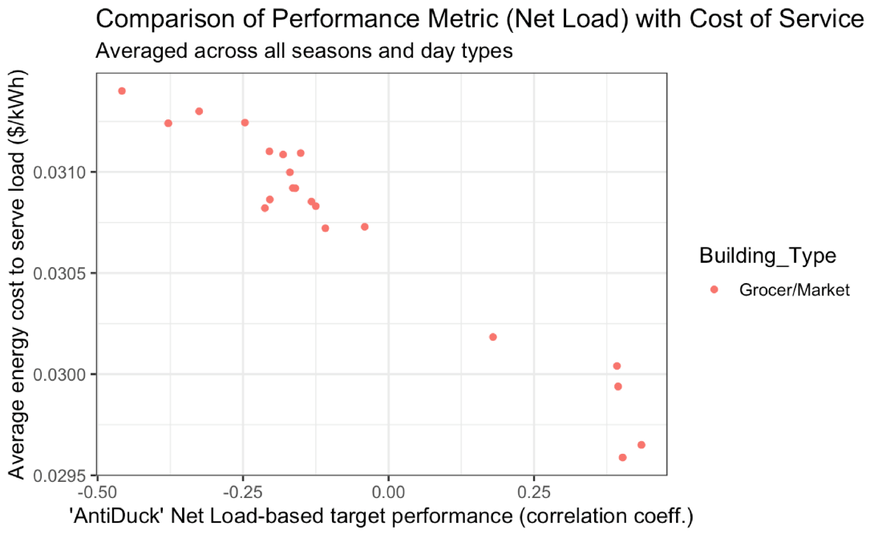
What are the expected challenges: This is not an approach that has previously been tried, so pilots would be needed to understand key design concepts for this product. There will be challenges in customer education and supporting customers to respond. Devices with automatic response would need to be programmed appropriately to receive published targets and respond appropriately.
What are potential solutions:
- modeling study to establish the possible value to the power system
- retail pilot study to understand the customer acquisition, response, and retention process
- technology pilots to measure the capabilities of automation technologies

Contract Characteristics:
Does a contract or tariff for this product exist: TBD

If a contract does not exist, complete the following
- Contract/tariff duration:
- Time/Location of response specified:
- Reference price or market-based:

Product Evaluation
The goal of this section is to elaborate on the characteristics of the product and its expected implementation for a set of evaluation criteria that can aid judgement on the merits / value.

Market integration

Describe how this product is linked with the CAISO energy market.
Is it intended to be directly dispatchable by CAISO: No
If yes, does it fit into an existing market model: No
What changes to policy or practice are required: CAISO markets require no changes.

Is the product dispatched outside of the CAISO market, but reasonably considered “market integrated”: Yes. The product would have both indirect and direct effects on market operations. The indirect effects would come from day-to-day customer response to the target load shapes. These responses would change the operations of the real-time market based on the shifts in consumption. The direct effects on the market would come from changes in “load bidding” behavior by LSE’s as experience is gained in observing customer response (assuming adoption and response is sufficient to change load forecast outcomes).

Grid Needs Match
What grid needs does this product solve: The broad grid needs served by the PLS concept are listed here:
- reduced cost of service for energy
- reduced curtailment
- reduced greenhouse gas
- reduced peak capacity requirement
- reduced flexible ramping capacity requirements
- avoided distribution system investment costs (with appropriate modifications based on need)
avoided transmission system investment costs (with appropriate modifications based on need)

Does this product enable the resource to also provide other services (i.e., dual participation)? What additional services does it enable: Since the product is out-of-market it could be possible for customers to also participate in other market-integrated programs without issues related to “double dispatch.” A PLS product could be tightly integrated with pay-for-performance EE.

How do the dispatch details (described previously in product description section) inform its value to the grid? For example, describe the response time, notification, geographic granularity, etc. and how this supports grid needs: The response time for this product is very long – months in advance. This focuses the value of the product on long-term average effects from restructured load: reducing the cost of service in the energy market, avoiding curtailment, reducing greenhouse gas.
The capacity value of PLS would depend on broad, aggregated effects in the system wide load, and would need to be based on the effects in forecasted needs for generation and T&D capacity.
With SubLAP geographic granularity, it would be possible to focus on the cost of service for local areas with different marginal resources and capacity needs.
Finer grain geographic dispatch could reflect the constraints and needs on distribution feeders and circuits.
For each of the grid needs identified in the list above, describe:
- How can the magnitude of value be estimated: Reduced cost is based on comparing cost of serving loads between customers who are in/out of the program (for example). Reduced curtailment and GHG is estimated based on program evaluation. Reduced peak, flex, transmission, and distribution capacity is based on program evaluation
- Is there an existing revenue mechanism accessible: The expenditures LSEs make on behalf of their customers for serving load is the core revenue mechanism for energy cost savings (i.e., “avoided” expenditure is a revenue source). New processes would need to be established for estimating and accounting for these. Revenue for GHG and curtailment -- would be new. Revenue for reduced cost of capacity would be based on estimates of avoided cost --- would be new
- What Is the minimum kW / kWh size: None technically. Sub-metering may be required if responding loads are small compared to site-level load.
- What is the maximum kW / kWh size: None technically. Program limits could constrain.

Is the product delivering an incremental service: It depends on the specifics of the settlement design.
This product would provide new signals and targets for load response that are more specific and could have higher effective price ratios than existing TOU and other long-term load shift.

There are two broad categories of settlement design:
- Simple comparison to the target: ensures simplicity in settlement, but may lead to some free-ridership (non-incrementality).
- Comparison to site-level estimated baseline: requires complex baseline average load shapes to establish non-participating baseline, with diminishing ability to estimate baselines for long-duration customer participation.
It is possible that some customers are structural winners who already have a load shape that is closer to the system or local target. For these customers, some “free-ridership” could occur if the scoring for customer response is based on simple comparison to the target shape without reference to a before-program baseline. These “free riders” would in principle be the customers who already have loads that are less expensive or less environmentally impactful to serve, so any the incentives are in some sense returning value to these customers that they have been creating for some time.
Eliminating free-ridership issues completely, in the pursuit of strictly incremental scoring, would require customer-level baselines to be estimated. Since PLS is a long-term and persistent response, these would be particularly challenging compared to event-level baselines.
In the face of this tension between allowing structural winners and requiring significantly challenging baselines, some concepts for implementing a deployment based on simple comparisons with the target are:
- Set a fixed pool of incentives based on careful program evaluation, which would estimate value from the range of “grid needs” described above. Determining how much of the value is incremental vs. structural transfers from non-participating customers with less favorable load shapes could be one of the focus areas. The overall program value to the ratepayers, across a range of value streams, could form the basis for determining the total availability of incentives and/or performance payments to be allocated to participants.
- Structure a retail-facing implementation of PLS to have the pool of customers who are participating compete within the participating customer pool for increased incentives when their response is better than the typical participating customer. This has the benefits of incentivizing incremental changes in loads, and creating incentives for “free riders” to do more to capture value.
How is the incremental value determined: The calculation would depend on the specifics of product design. See discussion above.

Customer Experience
What is the anticipated ability of customers to respond to the product in the time frame and geographical time space suggested: P4LS is broadly applicable. Many different customers could respond in different ways.
Are there particular customer co-benefits related to participating: If TOU rates are roughly aligned with PLS dispatch, customers could also experience bill savings from shifting loads. Alignment in approach with performance-based EE could unlock value from co-delivered programs.

What are the likely use cases where participant economic benefit coincides with grid needs (e.g. scheduling an extra production shift during low price periods): Scheduling an extra production shift or increased production during low price (high consumption target) periods (e.g., with industrial production, municipal pumping, water processes, etc.). Charging electric vehicles at times when the marginal cost / emissions of energy is low, reducing the cost of transportation service
What are the challenges and opportunities for participation across customer classes (residential, small commercial, large commercial, industrial, agriculture, municipal, etc.): Industrial and municipal loads that have some long-term requirement for production volume but flexibility in the specific scheduling of processes may be particularly well suited to PLS. The relatively long notification time and persistence for the product (on the monthly timescale) could be favorable for scheduling flexible but process loads with a predictable and stable target.
Residential, small commercial, and large commercial customers have could be targeted by aggregators who identify opportunities for aggregations of customers to participate. The specifics of load flexibility by customer class, the end-use(s) being modified, and retail offers to incentivize participation could be identified by competitive third-party aggregators.
Some customers may not have inherently flexible loads or scheduling and would not benefit from participation. These customers could in principle choose not to participate, or if they participate would not receive high incentive payments. Customers in an aggregation who are below-average performers would tend to reduce the overall average performance of the group, but could still in principle receive incentives for participation from an aggregator (depending on the retail model that is deployed).
Can current DR-providing customers participate without significant control technology upgrades: Some can and some cannot. Those with “bidirectional” ability to modify load could participate (e.g., communicating thermostats, production scheduling, etc.). Those with only “shed” control (e.g., DLC switch) would need additional or upgraded technology.

Potential Ratepayer Costs
Grid IT Systems
Describe how the product is compatible with existing utility IT/metering/billing systems.

Does retail meter data granularity meet product needs: Yes
Do overall utility IT systems meet product needs: Not yet

If no to any above, what changes may be warranted: Utilities and LSE’s would need to establish methods for forecasting the cost and emissions related to serving customer loads, and use these forecasts to develop target load shapes.
There would need to be a settlement process developed and deployed to score customer responses compared to the target and allocate incentives and/or payments for performance.

What are potential challenges/costs of those changes: Since there are not complex daily transactions involved, and the settlements can be established long after the fact, the technical requirements for the IT systems are relatively low cost compared to other, faster-dispatch Shift.
The core challenge for IT may be related to the eventual formulas that are defined for forecasting target load shapes, and scoring customer performance against the target. If these formulas change over time in response to regulatory oversight or improvements, it would mean updating the algorithms. The data extraction and management overhead would likely not require as frequent updates and changes after it is developed initially.

What are potential spillover benefits of those changes: The same systems required to support this kind of service would be required to support real-time pricing.
PLS customers could receive distribution system target load shapes that reduce the cost of service related to distribution system capacity.

Other Ratepayer Costs
Incentives:
Lost Revenues:
Other:

Greenhouse Gas
What are the expected greenhouse gas emissions impacts from implementing the product: The “anti-duck curve” is the proposed core driver for defining the target load shape (with possible contributions from marginal price and emissions forecasts). Because of the structure of the CAISO energy market with positive correlation between marginal prices and emissions, this fundamental approach would tend to reduce the average emissions. Avoided curtailment would further improve the GHG performance of the PLS product.

Appendix E

Sunrun Market Integrated

Product Description

Product Name: Sunrun Market Integrated
Short Description: Under this market integrated load shift participation model, a customer commits with an aggregator to provide load consumption capacity and load curtailment capacity as dispatched by the distribution system operator. Within a specific load consumption time domain, the distribution system operator will dispatch, via aggregator, available load consumption capacity in response to Proxy Demand Response - Load Shift Resource (PDR-LSR) negative pricing signals (Regulation Down Capacity). Similarly, within a specific load curtailment time domain, RA resources will follow PDR-LSR rules, but non-RA resources will instead offer incremental exceptional capacity dispatch services. This incremental exceptional capacity dispatch service enables, within seconds, aggregated export of idle capacity in reserves to directly support the grid during time of need. There are multiple use applications within the distribution domain, including distribution operations and planning, grid modernization, and Interconnection Capacity Analysis; the hosting capacity can be expanded to manage reverse power flow and enable a greater number of DERs to connect on the feeder and customer service node without infrastructure upgrade. For example,an existing NEM PV system installs storage and commits to limit exports within the load consumption time period and export within the load curtailment time domain when dispatched by the aggregator in response to command from distribution system operator for PDR-LSR capacity services, exceptional incremental dispatch for non-RA resources, or distribution operations management. This is one of many use cases where customers can significantly alter their load shape, ensuring a technology neutral approach for customers that can provide these capacity services per future program rules.
Dispatch Method and Granularity

How are loads dispatched or instructed to shift: DERs and end user load building resources are dispatched from an aggregator to deliver load consumption within the daytime excess energy domain and load curtailment capacity within the system ramping and peaking domain as dispatched by distribution system operator to align with greatest planning need.
- What is the time and spatial granularity?
  - Time step of dispatch signal: Seconds
  - Advance notice time to customer: Seconds
  - Scale of geographic detail [circuit-feeder-PNode-SubLAP-DLAP-ISO]: Circuit-feeder
  - Expected frequency of dispatch: Per program rules and distribution system operational and planning needs as well as CAISO PDR-LSR or incremental exceptional dispatch
  - What is the triggering signal: Distribution system need, PDR-LSR dispatch, or distribution system operator incremental exceptional dispatch.
  - Is signal modified before dispatch: May vary by program design.

Organizational Roles

Describe responsibilities, relationship, and payments between the following parties.

Customer: Rider Tariff Customer

Third Party / Aggregator: Capacity, telemetry, and dispatch.

Load Serving Entity (CCA or IOU or DA provider): Capacity Payments.

Distribution utility / service territory LSE (IOU): Planning and operational coordination.

CAISO: PDR-LRS and possible MUA in other time domain.

Regulator (CPUC or FERC):

Participating load / device boundary and settlement

This set of criteria clarifies the options for participation by devices and/or premises-level load.

Is the product technology neutral: Yes

What is the smallest intended boundary for settlement: Device

Sub-metering needs / value: Accept device level data for aggregation if available

What is the settlement process (i.e., how is value estimated and performance verified): Telemetered reporting per program rules with monthly invoicing including performance metrics based on aggregated metered response.
- Aggregator role: Telemetered reporting per program rules with monthly invoicing/settlement.
- LSE role: Enable shared ratepayer savings from services provided by DER owner/customers and distribution system operator.
- CAISO role: PDR-LRS and possible MUA in other time domain.

How will performance be measured: Aggregated device level with baseline solely for PDR-LSR performance.

What are the expected challenges: TBD

What are potential solutions: Develop a study to understand power system planning benefits to evaluate appropriate program structure and distribution system operator needs to implement.

Contract Characteristics
Does a contract or tariff for this product exist:

If a contract does not exist, complete the following
- Contract/tariff duration:
- Time/Location of response specified:
- Reference price or market-based:

Product Evaluation
The goal of this section is to elaborate on the characteristics of the product and its expected implementation for a set of evaluation criteria that can aid judgement on the merits / value.

Market Integration
Describe how this product is linked with the CAISO energy market: Distribution system operator bids load consumption capacity that is not being utilized for distribution operations within CAISO’s proposed PDR-LSR. Within the peak load curtailment time domain, the distribution system operator may schedule RA capacity per PDR-LSR rules. Non-RA resources will offer incremental exception dispatch rights to the distribution system operator, which can be utilized per product rules and may or may not be market integrated, but directly dispatched during abnormal periods of need.
Is it intended to be directly dispatchable by CAISO: Yes via distribution system operator and 3rd party aggregator dispatch.
If yes, does it fit into an existing market model: Distribution system operator acts as scheduling coordinator with dispatch telemetry to 3rd party DER customer aggregator.
What changes to policy or practice are required: There are no existing pathways for the distribution system operator to coordinate DERs via rider tariffs for load consumption and load curtailment capacity services.

Is the product dispatched outside of the CAISO market, but reasonably considered “market integrated”: This products is market integrated as the distribution system operator will bid capacity within CAISO’s planned PDR-LSR product. Non-RA resources will be bid within load consumption period, but offer the distribution system operator incremental exceptional dispatch rights to utilize for peaking capacity service in time of need. Distribution system operator may dispatch outside of CAISO market for distribution load consumption and peak capacity services to address local grid needs.

Grid needs match
What grid needs does this product solve: At the bulk power system level, this product aligns with CAISO’s excess energy, ramping, and peaking planning needs with envisioned market integrated participation with PDR-LSR. Where non-RA resources have no dispatch requirements under the proposed PDR-LSR rules, we are proposing non-RA resources offer a new form of ramping/peaking capacity as an incremental exceptional dispatch capacity service, enabling dispatch by the distribution system operator per future product rules.
Distribution capacity deferral in the form of load consumption capacity (renewable energy/DER hosting capacity expansion/distribution reliability) domain and encompases the core grid planning needs of low cost dispatch, low pollution, high reliability, and equality of service.

Does this product enable the resource to also provide other services (i.e., dual participation)? What additional services does it enable: Varies by resource capabilities, but this product is designed to enable MUA capacity for distribution capacity, frequency regulation down, as well as ramping and peaking capacity services.
How do the dispatch details (described previously in product description section) inform its value to the grid? For example, describe the response time, notification, geographic granularity, etc. and how this supports grid needs: The distributions system operator acting as the scheduling coordinator will bid available load consumption capacity within PDR-LSR. When resources are dispatched, third party aggregators will telemeter dispatch to DERs per PDR-LSR rules. Non-RA resources will be bid within load consumption period, but offer the distribution system operator incremental exceptional dispatch rights to utilize for peaking capacity service in time of need.
The typically coincidental CAISO and feeder level excess energy capacity needs have significant distribution planning benefits if coordinated. These capacity services if coordinated enables managing of reverse power flow, improved voltage management, enables more DERs to easily interconnect along the entire distribution feeder during normal an abnormal configurations, whereby the existing distribution infrastructures capacity can be expanded as a non wire alternative based on this products rules.

For each of the grid needs identified in the list above, describe:
- How can the magnitude of value be estimated: Forecasted interconnection upgrade savings, grid modernization savings, CAISO excess energy and peak payments.
- Is there an existing revenue mechanism accessible: No, recommend a study to assess benefits of product/program approach.
- What Is the minimum kW / kWh size: 1kW/3kWh
- What is the maximum kW / kWh size: Generator facility capacity and/or site load modifying behaviours for 5 hours

Is the product delivering an incremental service: Yes
How is the incremental value determined: A generating facilities capacity curtailment and dispatch control aligned with future product rules is incremental as the customer is foregoing the exports or possibly self consumption benefits which they would otherwise be receiving. Dispatch capacity within the load curtailment period is an incremental capacity service. Customers without existing generating facilities can commit and deliver load building capacity by various means and methods to align with future program rules.

Customer Experience
What is the anticipated ability of customers to respond to the product in the time frame and geographical time space suggested: Per aggregator agreement and program rules, DERs will enable telemetry to ensure desired response in accordance with program rules.
Are there particular customer co-benefits related to participating: If the program enables a customer to capture capacity service values across the power system domains, which in turn enables a customer to justify storage investment. The customer can have co-benefits such as resiliency, which can be a powerful driver for customers desiring storage as well as increased renewable self consumption.
What are the likely use cases where participant economic benefit coincides with grid needs (e.g. scheduling an extra production shift during low price periods): Economic benefits created based this products coordination across power system domains is broad including but not limited to DER sales/installation, DER customer/owner, aggregator, distribution system operator, and all California electric consumers.
Building modernization strategies aligned with program/grid needs, may enable unknown economic benefits.
Rider tariffs enabling upgrade of existing NEM resources or commitments by new NEM resources to provide incremental services or customer adoption of energy storage are possible use cases.
What are the challenges and opportunities for participation across customer classes (residential, small commercial, large commercial, industrial, agriculture, municipal, etc.): We anticipate that additional customer education and outreach will be needed to enable customer understanding of this program.
Can current DR-providing customers participate without significant control technology upgrades: Yes if no MUA conflict.

Potential Ratepayer Costs
Grid IT Systems
Describe how the product is compatible with existing utility IT/metering/billing systems.

Does retail meter data granularity meet product needs: No, but can verify compliance for some resources depending on future program rules.
Do overall utility IT systems meet product needs: Assume yes as this is not IT intensive, until further DSO capabilities are developed to automate dispatch. Overtime ICA mapping capabilities will need to be updated to account for service nodes and hosting capacity expansion benefits from customer adoption of this product. Utility processes for interconnection, distribution planning and operations, and scheduling coordination will need to evolve to enable this product in coordination with 3rd party aggregators.
If no to any above, what changes may be warranted: N/A
What are potential challenges/costs of those changes: N/A
What are potential spillover benefits of those changes: N/A

Other Ratepayer Costs
Incentives:
Lost Revenues:
Other:

Greenhouse Gas
What are the expected greenhouse gas emissions impacts from implementing the product: A positive GHG impact is assumed. The program will expand the hosting capacity of the distribution and CAISO system to interconnect future GHG free sources during and enable multiple use applications for existing renewable resources.

Appendix F

Sunrun Market Informed

Product Description

Product Name: Sunrun Market Informed

Short Description: Under this market informed scheduled load shaping participation model, a customer commits to permanently/seasonally to effectuate load consumption and load curtailment capacity within the defined periods of need. Within this load consumption time domain, these capacity resources will enable more renewables on the bulk power system and reduce the chances of negative pricing from occuring on the CAISO system. Within the load curtailment time domain, these capacity resources will deliver capacity for specified hours of ramping and peaking system needs. There are multiple use applications within the distribution domain, including distribution operations and planning, grid modernization, and Interconnection Capacity Analysis; the hosting capacity can be expanded to manage reverse power flow and enable a greater number of DERs to connect on the feeder and customer service node without infrastructure upgrade. For example, an existing NEM PV system installs storage and seasonally/permanently commits to deliver capacity within this load shift time domains. These capacity resources will limit power export within the load consumption domain and deliver/export capacity during the load curtailment time period. This is one of likely many use cases where customers can significantly alter their load shape, ensuring a technology neutral approach for customers that can provide these capacity services per future program rules.

Dispatch Method and Granularity
How are loads dispatched or instructed to shift: DERs and end user load management resources are scheduled to deliver load consumption capacity and load curtailment capacity based on a permanent/seasonal schedule.
- What is the time and spatial granularity?
  - Time step of dispatch signal: N/A
  - Advance notice time to customer: N/A
  - Scale of geographic detail [circuit-feeder-PNode-SubLAP-DLAP-ISO]: circuit-feeder
  - Expected frequency of dispatch: Permanent/Seasonal
  - What is the triggering signal: Capacity alignment with CAISO excess energy, ramping, and peaking needs in coordinated with distribution planning needs.
  - Is signal modified before dispatch? N/A

Organizational Roles

Describe responsibilities, relationship, and payments between the following parties.

Customer: Rider Tariff Customer

Third Party / Aggregator: N/A, unless required for program rules

Load Serving Entity (CCA or IOU or DA provider): Capacity payments

Distribution utility / service territory LSE (IOU): Planning and operational coordination

CAISO: Planning and possible MUA depending on resource capabilities

Regulator (CPUC or FERC): N/A

Participating load / device boundary and settlement

This set of criteria clarifies the options for participation by devices and/or premises-level load.

Is the product technology neutral: Yes

What is the smallest intended boundary for settlement: Device

Sub-metering needs / value: Accept device level data if required

What is the settlement process (i.e., how is value estimated and performance verified): Where this is a scheduled capacity service, program rules can enable simplified meter verification approaches for rider tariff customers demonstrating continued compliance at the service meter following initial M&V compliance. Alternatively, if device level performance based settlement is needed, an aggregator model may be needed to support the program structure.
- Aggregator role: N/A unless future program rules require schedule updating
- LSE role: Enable shared ratepayer savings from services provided by DER owner/customers and distribution system operator.
- CAISO role: Possible MUA in other time domain.

How will performance be measured: Premises level verification with device level reporting without baseline, unless needed for resource type.

What are the expected challenges: Will future program benefits incent customer adoption?

What are potential solutions: Develop a study to understand power system planning benefits to evaluate appropriate product structure.

Contract Characteristics:
Does a contract or tariff for this product exist:

If a contract does not exist, complete the following
- Contract/tariff duration:
- Time/Location of response specified:
- Reference price or market-based:

Product Evaluation
The goal of this section is to elaborate on the characteristics of the product and its expected implementation for a set of evaluation criteria that can aid judgement on the merits / value.

Market Integration
Describe how this product is linked with the CAISO energy market: Program has operational alignment with CAISO excess energy, ramping, and peaking planning needs, but is not intended for market integration
Is it intended to be directly dispatchable by CAISO: No
If yes, does it fit into an existing market model: N/A
What changes to policy or practice are required: N/A

Is the product dispatched outside of the CAISO market, but reasonably considered “market integrated”: Yes, the product is considered to be market informed, since capacity services align with CAISO daytime excess energy, ramp, and peak planning needs.

Grid needs match
What grid needs does this product solve: On the bulk power system level, the product aligns with planning needs within multiple CAISO’s planning domains. Within the daytime excess energy domain customers of varying resources and technology types commit to schedule load consumption capacity on an ongoing basis to address current and future grid needs for California as a countermeasure to the “Duck Curve”. Within CAISO’s ramping/peaking domain customers of varying resources and technology types commit to schedule load curtailment capacity on an ongoing basis to address current and future grid needs for California.

Distribution capacity deferral in the form of load consumption capacity (renewable energy/DER hosting capacity expansion/distribution reliability) and load curtailment peaking capacity encompases the core grid planning needs of low cost dispatch, low pollution, high reliability, and equality of service. Unlike a time of use rate, the permanently scheduled operational characteristics provide superior distribution planning benefits enabling significantly more deferral opportunity of existing infrastructure capacity.

Does this product enable the resource to also provide other services (i.e., dual participation): What additional services does it enable: Varies by resource capabilities, but this product is designed to enable MUA capacity benefits for distribution and bulk system within multiple time domains, and may enable MUA’s within other time domains for some resources.

How do the dispatch details (described previously in product description section) inform its value to the grid? For example, describe the response time, notification, geographic granularity, etc. and how this supports grid needs: The scheduled nature of the resource makes the program easy to administer and a powerful grid planning tool. The typically coincidental CAISO and feeder level excess energy and peaking capacity needs can have significant distribution planning benefits if coordinated. This capacity coordination includes improved voltage management and enabling more DERs to easily interconnect on shared service nodes and along the entire distribution feeder, whereby the existing distribution infrastructures capacity to interconnect DERs can be expanded as a non wire alternative based on this program design.

For each of the grid needs identified in the list above, describe:
- How can the magnitude of value be estimated: Forecasted interconnection upgrade savings, grid modernization savings, along with CAISO excess energy and peaking capacity savings.
- Is there an existing revenue mechanism accessible: No, recommend a study to assess benefits of product/program approach.
- What Is the minimum kW / kWh size: 1kW/3kWh
What is the maximum kW / kWh size: Generator facility capacity and/or site load modifying behaviours/resources for 5 hours.

Is the product delivering an incremental service: Yes

How is the incremental value determined: A scheduled generating facilities capacity curtailment and export aligned with future program rules is incremental as the customer is foregoing the exports or possibly self consumption benefits which they would otherwise be receiving. Customers without existing generating facilities can commit and deliver load building and peaking capacity by various means and methods to align with future program rules.

Customer Experience
What is the anticipated ability of customers to respond to the product in the time frame and geographical time space suggested: Existing inverter technologies have capabilities today for programming at installations or remotely ensuring desired response in accordance with program rules.
Are there particular customer co-benefits related to participating: If the program enables a customer to capture capacity service values across the power system domains, which in turn enables a customer to justify storage investment. The customer can have co-benefits, such as, resiliency which can be a powerful driver for customers desiring storage as well as increased renewable self consumption.
What are the likely use cases where participant economic benefit coincides with grid needs (e.g. scheduling an extra production shift during low price periods): Economic benefits created based on this products coordination across power system domains is broad including but not limited to DER sales/installation, DER customer/owner, aggregator, distribution system operator, and all California electric consumers.
Building modernization strategies aligned with program/grid needs, may enable unknown economic benefits.
Rider tariffs enabling upgrade of existing NEM resources or commitments by new NEM resources to provide incremental services or customer adoption of energy storage are possible use cases.

What are the challenges and opportunities for participation across customer classes (residential, small commercial, large commercial, industrial, agriculture, municipal, etc.): We anticipate that additional customer education and outreach will be needed to enable customer understanding of this program.
Can current DR-providing customers participate without significant control technology upgrades: Yes if no MUA conflict.

Potential Ratepayer Costs
Grid IT Systems
Describe how the product is compatible with existing utility IT/metering/billing systems.

Does retail meter data granularity meet product needs: No, but can verify compliance for some resources depending on future program rules.
Do overall utility IT systems meet product needs: Assume yes as this is not IT intensive, but requires new DSO processes to be developed for hosting capacity expansion coordination. Overtime ICA mapping capabilities will need to be updated to account for service nodes and hosting capacity expansion benefits from customer adoption of this product.

If no to any above, what changes may be warranted: N/A
What are potential challenges/costs of those changes: N/A
What are potential spillover benefits of those changes: N/A

Other Ratepayer Costs
Incentives:
Lost Revenues:
Other:

Greenhouse Gas
What are the expected greenhouse gas emissions impacts from implementing the product: A positive GHG impact is assumed for the following reasons: Program will expand the hosting capacity of the distribution and CAISO system to interconnect future GHG free sources during and enable multiple use applications for existing renewable resources.

http://www.caiso.com/Documents/Wind_SolarReal-TimeDispatchCurtailmentReportOct08_2018.pdf
The CAISO’s DA market run results are supposed to be announced by 2 pm, but they can occur later in the afternoon.
Depending on the level of detail in circuit- or feeder-level modifications to the target load shape, information about the constraints and characteristics of the distribution system may be revealed through publication of the targets. The distribution system operator should participate in the process of defining the level of detail for modifications and plans for publication.

