Load Shift Working Group: Final Report
December 17, 2018

Executive Summary
As California progresses toward its goal of 100% carbon-free electricity, Load Shift could play an increasingly significant role. Load Shift means enabling and incentivizing customers to meet their electricity needs (“take”) during periods of surplus generation, lower energy prices, and lower emissions, while minimizing their consumption (“shed”) during periods of scarcity, high prices and higher emissions. As California’s electricity grid has embraced increased renewable generation, its load shape has shifted from the historical mid-day peak load demand, to a changing load shape wherein mid-day renewables overgeneration has shifted the grid’s net load peak to later in the day and evening (see Figure 1 below). A wide range of existing and emerging technologies are able to provide Load Shift now and the benefits of doing so are growing. Studies suggest beginning in 2025 up to $600 million ($2015) could be saved annually by shifting load to avoid the curtailment of renewable generation. And this value assessment grows when other benefits are considered (e.g., resource adequacy) and higher levels of renewable penetration are assumed.

This Report documents the efforts of a Load Shift Working Group (LSWG) led by the California Public Utilities Commission (Commission) to determine and evaluate viable Load Shift product designs. Working collaboratively, a representative cross-section of stakeholders developed six different proposals on how Load Shift could be designed, sourced, incentivized and evaluated. The proposals aim to serve a range of grid needs, beginning with helping to avoid renewable generator curtailment. The proposals rely on a variety of dispatch methods, price and greenhouse gas (GHG) signals, and load schedules to prompt customers to increase or decrease their usage in line with available, zero-marginal cost renewable generation. This package of proposals provides a diverse range of options through which California can begin to actively test, refine and develop the Load Shift market needed to reach a 100% carbon-free grid.

In support of the proposals advanced by this Report, the LSWG considered how California’s approach to resource adequacy, data access, coordination with the California Independent System Operator (CAISO), and assessing greenhouse gas. In considering these issues, and many others, the LSWG identifies regulatory obstacles to achieving Load Shift, but concludes those obstacles are not insurmountable. Based on this assessment, the LSWG recommends California bring new focus and energy to developing Load Shift as a resource. To begin, the Commission should invite pilots along the lines of the proposals envisioned here in early 2019. With active oversight, refinement and support such pilots could lead to a mature, significant Load Shift resource by 2025.

Introduction

Challenges Emerging from Renewable Integration
California has substantially increased its share of electricity consumption met by renewable energy, reaching 32% of retail sales in California in 2017. Today more than 23,000 MW of intermittent resources are operational, including over 5,000 MW of wind and 17,000 MW of solar. Because these renewable resources are “fueled” by wind and sun, they introduce new variability to power system operations based on natural cycles and the weather.

Figure 1: California's Projected Net Electricity Load 2012-2020
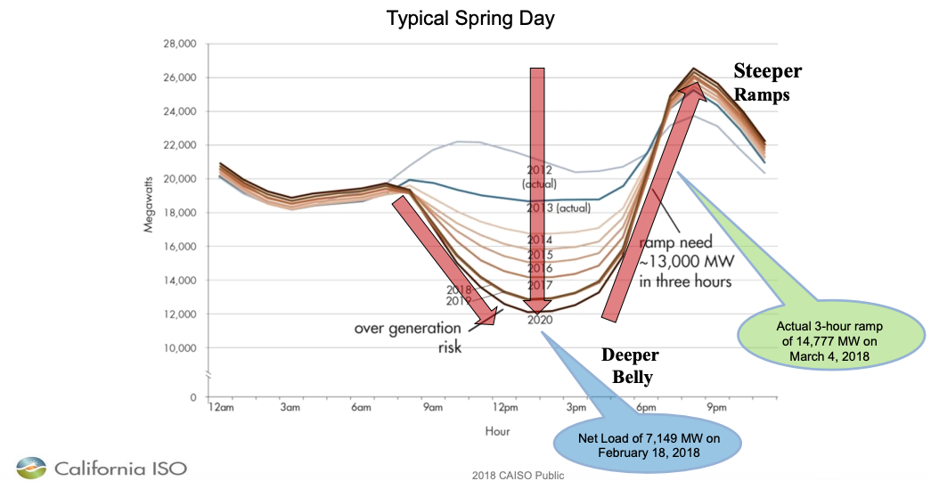

As illustrated in Figure 1, two challenges emerge from California’s new renewable power supplies: an oversupply of mid-day generation, which contributes to renewable generation curtailment, and significant ramps in the morning and evening, which are demands on non-solar resources to respond to the beginning and end of solar’s production cycle. Adding to the complexity, the impacts of oversupply and ramping vary season-to-season, day-to-day, and location-to-location.

CAISO market data show an acceleration in negative market prices and renewable curtailment, two leading symptoms of oversupply. In 2017, average system marginal day-ahead energy prices fell below zero in over 110 hours, all during midday hours in the first two quarters with high levels of solar generation and high hydro conditions. In comparison, these prices were negative during only three hours during all of 2016. Figure 3 shows an upward trend in economic curtailment over the past three years. Roughly half of this curtailment occurs locally, the result of oversupply within a transmission constrained area, while the other half is system-wide.
Figure 2: California Wind and Solar Monthly Curtailments
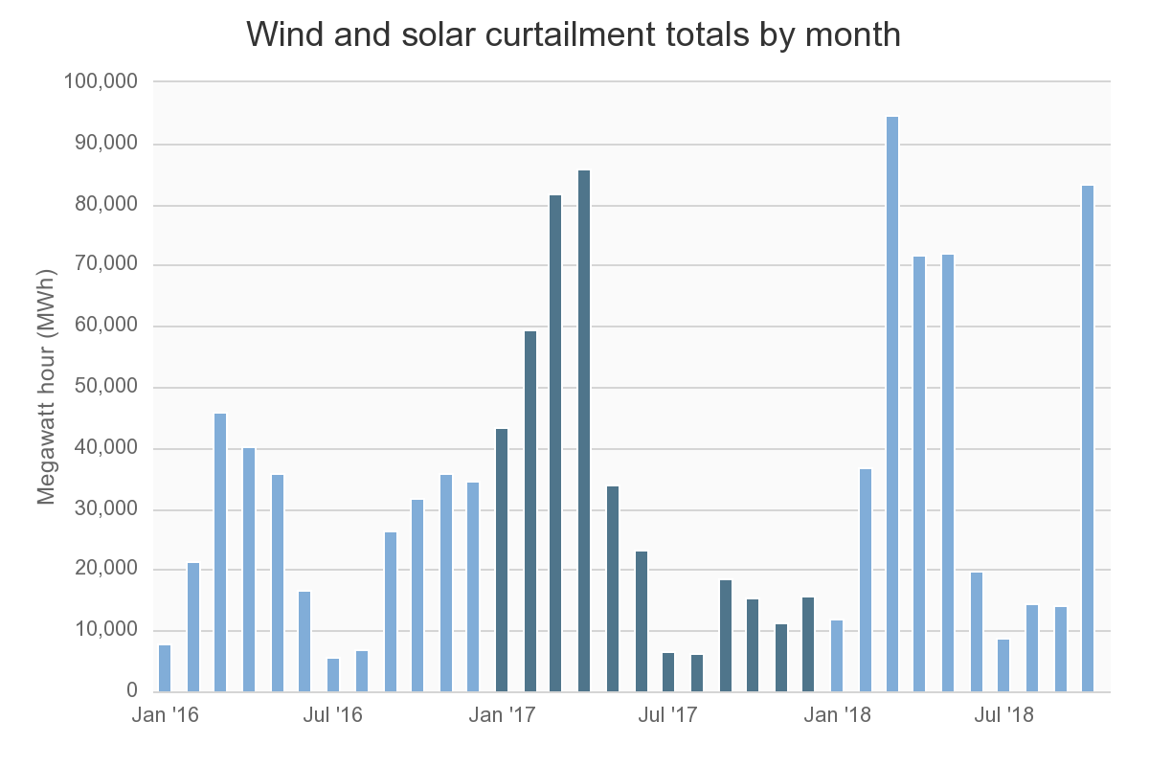
These challenges have been a regular part of California’s clean energy discussion since the introduction of the California Independent System Operator’s Duck Curve in 2011. But recent events underscore the urgency of addressing them: in 2018 California’s oversupply and ramping demands reached levels almost four years ahead of what was originally forecasted. Meanwhile, with the adoption of SB 100, California deepened its commitment to increasing the key contributing factors of the “duck curve” setting the bold goal of powering California with 100% clean, carbon-free electricity by 2045.

Addressing Challenges of Renewable Integration
Solutions to these challenges include a wide-range of policy, market, and infrastructure changes, including: better alignment of retail rates with the cost of service, broader power exchanges across the western region, more available flexible generation, the deployment of energy storage and the focus of this report: Load Shift. The intent of Load Shift is coordinated, targeted modification of customer energy consumption timing to better align with low cost, low pollution power generation resources. In practice, load shift means enabling and incentivizing customers to meet their electricity needs (“take”) during periods of surplus generation and lower energy prices/emissions, while minimizing their consumption (“shed”) during periods of renewable scarcity and relatively high energy prices/emissions. This dynamic is illustrated in Figure 3.
Figure 3: Targeted Load Shift Schedule
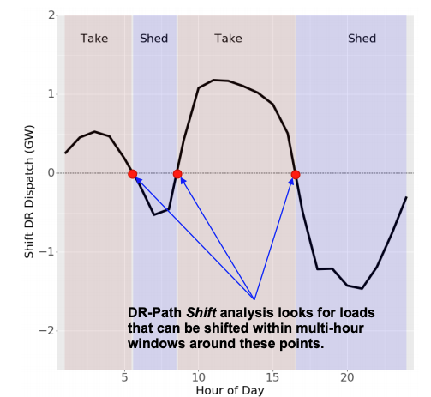
Source: Lawrence Berkeley National Laboratory
This Figure shows the inverse of the duck curve, illustrating a target Load Shift schedule that would complement renewable power supplies through take (pink areas) during periods of oversupply and shed (blue areas) during periods of scarcity.

The Potential for Load Shift
In 2015 the California Public Utilities Commission (Commission) sponsored a study by the Lawrence Berkeley National Lab (LBNL) to assess the potential for Demand Response to meet ongoing and emerging grid needs in California. According to the study, by 2025 California could shift between 10-20 GWh (2-5% of daily load) of load. Further, the study concludes shifting load could save between $200-600 million ($2015) in costs associated with curtailing renewable generation. SB100, adopted subsequent to the completion of these estimates, likely increases their magnitude.

Based on LBNL’s study, estimated cost reductions made possible by Load Shift are primarily the result of avoiding renewable power overgeneration and curtailment. Put simply: effective Load Shift strategies allow more of California’s renewable generation to serve California’s customers rather than being curtailed or exported. Absent this solution, fulfilling the state’s renewable energy goals would require incremental renewable generators, which would continue making positive contributions during periods of high-load, but in turn deepen the duck curve challenges during periods of low-load. This conclusion has been underscored by subsequent analysis. The Commission’s 2017 Integrated Resource Planning Modeling, completed by E3 with guidance from the Commission, recommended Load Shift as a valuable contribution to long term resource portfolios.
Addressing Need for Capacity, Distribution Service, and Customer Bill Management
Beyond avoided renewable generator curtailment, additional benefits can accrue through well-timed, well-placed Load Shift resources. A summary of these benefits include:

- Energy Cost Reductions: By reducing the need to dispatch conventional generators, Load Shift has the potential to lower the marginal cost of generation in both day-ahead and real-time energy markets;
- Emission Reductions: Where conventional generator dispatch is avoided, Load Shift also reduces both GHG emissions and local particulates, contributing to the mitigation of climate change, improving local air quality, encouraging environmental justice, and supporting good health and well-being;
- System, Local and Flexible Resource Adequacy: As explained in additional depth on page 26, Load Shift has the potential to reduce peak and ramping needs, at both the system and local level;
- Transmission Capacity: Like the impact on resource adequacy demands, Load Shift may contribute to a reduced need for high-voltage transmission;
- Distribution System Services: Load Shift may reduce the cost of distribution systems while easing operations by giving operators new flexibility to shift load off circuit peaks, increase load in locations where distributed generation currently exceeds demand, and where the resource is inverter based, support voltage regulation;
- Customer Bill Savings: Load Shift provides customers the opportunity to reduce both volumetric and demand charges, shifting their consumption to periods of relatively low costs.

These benefits could be substantial and significant, but they are not guaranteed. Beyond avoiding renewable curtailment, the LBNL Study did not quantify these potential benefits, so the potential upsides specific to Load Shift have not been considered, nor have their costs. Furthermore, uncoordinated and untargeted Load Shift could also raise costs in each of these categories, primarily by contributing to (rather than reducing) peak load. As the following section shows introduces, load can be shifted, but shift alone does not guarantee a positive outcome. To be effective, the Load Shift needs to be well-timed and well-placed.

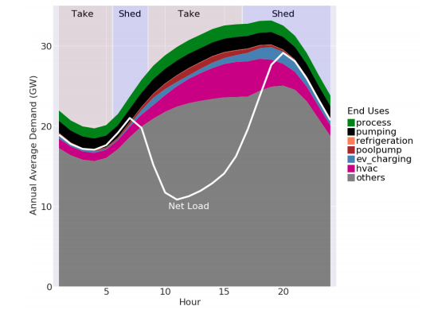
Sources of Load Shift
Sources of Load Shift can be found across commercial, industrial and residential customer classes, from both tested and emerging technologies. Electricity end-uses that can readily provide Load Shift include: air conditioning, refrigerated warehouses, water supply and treatment, commercial and industrial batch processes, and electric space and water heating. Emerging technologies stand to contribute as well, especially battery storage and electric vehicle charging. And all of these end uses are better prepared than ever to quickly and reliably deliver shift through automated responses to dispatch signals or preset schedules. Figures 4 illustrates these capabilities, showing the typical aggregate demand patterns for several shiftable load types in California, forecasted to 2025, along with the net load and times of need to Shift.

In sum, a compelling case has emerged for Load Shift, driven by current and forecasted grid conditions, estimates of value, and technological readiness. The remainder of the Report focuses on how California can begin to realize the potential of this resource.

LSWG Background and Report Organization

Commission Guidance
The Commission recognized the importance of Load Shift in D. 17-07-017, creating the Load Shift Working Group to develop a proposal for foundational elements of new models of demand response. The Commission gave the Working Group the following six tasks:

- Defining and developing new [Load Shift] products including load consumption and bi-directional products;
- Developing a proposal of whether and how to pay a capacity value for load consuming and bi-directional products to provide to the RA proceeding;
- Developing a list of data access issues relevant to new models that should be addressed prior to launching new models;
- Developing a proposal on how to better coordinate the efforts of CAISO and the Commission;
- Identifying the value of new products to provide to the Resource Adequacy proceeding; and
- Consideration of an energy storage emission metric for any energy storage related proposal.
The LSWG was first convened in-person in February 2018, meeting 11 times throughout 2018. The LSWG was facilitated and supported by Gridworks and the Commission’s Energy Division. The LSWG Includes 85 stakeholders representing 63 organizations. Collectively, these organizations comprehensively represent customers, providers of demand response services, utilities, and grid operators.

This report is intended to complete the six prescribed tasks and accomplish the Commission’s direction to “inform a new rulemaking for developing new models of demand response.” The central challenge addressed by the LSWG was to define and develop potential Load Shift products, therefore the heart of the report (“Product Proposals") are six diverse proposals on how California may go about developing its Load Shift resource. That central section of the report is bookended by the following additional sections:

- Evaluation Criteria: What Does Success Look Like? Identifying what the LSWG considered to be criteria of success for Load Shift product proposals;
- Proposal Evaluation: Comparing and contrasting product proposals relative to the LSWG’s key evaluation criteria;
- Responses to Commission Questions: Addressing specific questions of the Commission on resource adequacy, data access, coordination with CAISO, and GHG emission metrics;
- Recommendations: Recommending next steps for the Commission on Load Shift.

How the Report Reflects LSWG Member Perspectives
Consistent with the Decision’s direction, the report does not “resolve every issue thoroughly,” but rather provides a broad perspective and starting point for a new Commission rulemaking on how to modernize demand response. Recognizing this report serves as a starting point, it provides a collective expression of the LSWG rather than an account of every party’s position on every issue. Some parties disagree with some parts of the report, but agree the report provides a reasonable foundation. Where such disagreements are likely to carry into future consideration of Load Shift, this report highlights the issue using a pop-out box, as exemplified to the left.
Highlighting Issues
This report uses pop out boxes to highlight key issues that will likely require further consideration as Load Shift develops.

The LSWG hopes this report will help inform a new era of demand response with a new focus on renewable generation integration. The LSWG believes the topic warrants further and deeper engagement of stakeholders in California and beyond.

Load Shift Proposal Evaluation Criteria: What does success look like?

Guiding Principles
To facilitate the development of Load Shift product proposals, the LSWG developed a comprehensive Evaluation Framework to ensure product proposals reflect California’s priorities for the electricity system. In developing the Evaluation Framework, the LSWG relied on the Commission’s Decision 16-09-056 for guidance. This Decision provides the following goal and principles for demand response:

Goal:
Commission-regulated demand response programs shall assist the State in meeting its environmental objectives, cost-effectively meet the needs of the grid, and enable customers to meet their energy needs at a reduced cost.
Principles:
- Demand response shall evolve to complement the continuous changing needs of the grid;
- Demand response customers shall have the right to provide demand response through a service provider of their choice and Utilities shall support their choice by eliminating barriers to data access;
- Demand response shall be implemented in coordination with rate design;
- Demand response processes shall be transparent; and
- Demand response shall be market-driven leading to a competitive, technology-neutral, open-market in California with a preference for services provided by third-parties through performance-based contracts at competitively determined prices, and dispatched pursuant to wholesale or distribution market instructions, superseded only for emergency grid conditions.
Interpreting these principles in the context of Load Shift, the LSWG drew the following conclusions:

- Load Shift products should be technologically neutral, open to all sources and end uses.
- Load Shift products should reflect grid needs, especially integration of renewables, while accounting for customer needs and capabilities.
- Load Shift should not be “one-size fits all;” different customer classes, technologies, business models and stakeholders have value to add and should be encouraged.
Energy Neutral
The question of whether Load Shift should be energy neutral is significant. As a first step, the CAISO’s ESDER 3 process focused on energy storage (only) in part to ensure Load Shift is effectively energy neutral until the issue received a more thorough policy vetting. The CAISO’s concern was that take without shed could lead to unproductive outcomes and emission increases.
This Working Group considered this concern, concluding such outcomes were unlikely due to the mitigating impact of retail rates. As long as a customer has to pay a retail rate for additional consumption, frivolous consumption would be deterred by the additional cost which would result.

- Load Shift may include both “take” and “shed” and the two may be asymmetric. A requirement that any take be offset by an equal shed (an arrangement referred to as “energy neutral”) is technologically impractical for actual end-uses, technologically impractical for CAISO’s market optimization, and not necessarily representative of grid needs.

Evaluation Framework: Product Descriptions and Priority Criteria
Drawing on these guiding principles, the LSWG developed an evaluation framework requiring each proposal to provide a standard, detailed description of the product and to assess the strengths of each product relative to the same criteria. Appendices A-F to this report provide a completed evaluation framework for each product. From those full frameworks, the LSWG prioritized the following components to highlight here.
- Summary Description
- Dispatch Method and Granularity: How is the resources intended to be dispatched? Is it CAISO Market Integrated or otherwise informed by market prices? What are the locational and temporal limits to dispatch?
- Grid Needs: What grid needs does the product aim to address?
- Potential Costs: What are the potential costs to ratepayers?
- Accessibility to Customers: What is the anticipated ability of customers to respond to the product at the time and place needed?
- Performance Evaluation: How would the product’s performance be evaluated?
- GHG Impacts: What are the potential impacts on California’s greenhouse gas reduction targets?
- Regulatory Readiness: What additional regulatory steps would be needed for implementation?

The LSWG chose to highlight these components of the product proposals because they are reasonably reflective of California’s priorities for demand response and diverse enough to reflect meaningful differences between product proposals. Each product proposal was evaluated using these criteria, ensuring comparability between the products and consistency in evaluation. The following section addresses each component for each product proposal.

Products Proposals
The LSWG collaborated to create six diverse product proposals. The following sections summarize each proposal. Each proposal provides a distinct path through which California’s Load Shift capabilities could be developed. The proposals are not mutually exclusive, but many are complementary to various degrees.

Load Shift Resource 2.0
Summary Description: Load Shift Resource (LSR) 2.0 builds on the CAISO’s recently adopted proxy demand resource-load shift resource (PDR-LSR) product which enables battery storage devices to provide Load Shift. Key features of CAISO’s PDR-LSR include:
- builds on existing shed PDR model, allowing customers to take additional power at negative market prices down to the current price floor of -$150/MWh;
- requires the participant to use an energy storage device (i.e., a battery system) that can be sub-metered, allowing baseline measurement of energy charged and discharged at the energy storage device level;
- participating resource may be either shed or take with each being treated as a distinct resource by the CAISO;
- shed resources are eligible for resource adequacy (just as they are under existing PDR), while take resources are ineligible for resource adequacy capacity or ancillary services;
- resources must be able to participate in the real-time market and 15- or 5-minutes dispatchable.

PDR-LSR is not a product being proposed for further consideration by this LSWG because, as designed, the product is not technology neutral by only allowing battery storage to participate. To achieve technological neutrality, the LSWG developed the concept of LSR 2.0. Key changes to PDR-LSR would include a design that:
- applies to all technology types, rather than being limited to energy storage;
- allows for all approved baselines to be used to measure performance, rather than being limited to the methodology CAISO developed for use by sub-metered storage resources;
- can participate in day-ahead, real-time, or both markets;
- settles at the premise or the device level, rather than device level (only); and
- allows for bids for take that are positive, up to the CAISO’s net benefit test threshold, rather than negative prices (only).
Dispatch Method and Granularity: As summarized above, this product would be fully market integrated and dispatched by CAISO. With regards to locational granularity, PDR is dispatched at the resource level, which by default is as broad as a sub-LAP and can have a custom setup to be as narrow as a price node (Pnode); CAISO’s most granular point of visibility is a circuit substation, making market dispatch at the distribution level impossible. With regards to temporal granularity, LSR 2.0 would allow 15-minute intervals to be packaged into hourly blocks, giving customers an option to reduce their exposure to 15-minute market prices and associated complexity.

Grid Needs: LSR 2.0 would provide day-ahead or real-time energy through the CAISO markets, thereby contributing to avoided renewable curtailment. Shed resources would be resource adequacy eligible, consistent with current resource adequacy rules. Service of ramping needs through both shed and take may provide positive contributions to California’s need for flexible resource adequacy, although eligibility for direct flexible resource adequacy value is currently limited by resource adequacy rules.

Potential Costs: To the extent LSR 2.0 is determined to provide benefits beyond wholesale energy, the Commission may consider incentives commensurate with the value of those benefits.
Accessibility to Customers: Ability is analogous to current PDR-LSR customer experiences in meeting participation requirements and dispatch instructions.

Performance Evaluation: In 2018 FERC approved baseline calculation measures previously developed under the CAISO’s ESDER 2 process. It is possible LSR 2.0 could rely on these evaluation tools following further evaluation of their adequacy.
Performance Evaluation
Changes in the technologies and customer segments that now provide demand response introduce new evaluation challenges, including more frequent dispatch, device participation, bi-directional operation, and potentially export. These new challenges, which are not limited to Load Shift, will require time and resources to resolve.

Consideration of effective performance evaluation methodologies for Load Shift can be informed by the results of PG&E’s Excess Supply Pilot (XSP), which has been utilizing a reverse of the 10-in-10 baseline. Additionally, PG&E and researchers are examining the validity and accuracy of the ESDER 2 baselines when they are frequently used and bidirectional. The report is expected to be finalized in summer 2019 as part of PG&E DR Emerging Technology Assessment (DRET).

GHG Impacts: Exposure to CAISO market energy prices incentivizes LSR 2.0 participants to take at periods of negative- or low-pricing, which correlate strongly with periods of low emissions in the CAISO system, leading to the conclusion that LSR 2.0 would be unlikely to increase GHG emissions materially.

Regulatory Readiness: Product would require approval by CAISO, CPUC and FERC a following a stakeholder initiative focusing on the adaptation of the storage specific PDR-LSR for technological neutrality. It would also require equivalent new tariffs or contracts with the LSE. If additional incentives are warranted, determination of such incentives would also require CPUC consideration.

Critical Consumption Period
Summary Description: The Critical Consumption Period product is a retail load increase demand response product. Incremental load increase is triggered directly by the LSE based on negative wholesale Day-Ahead nodal market prices and paid (or pays) the real-time nodal wholesale market prices. The load increase (Critical Consumption) would occur during periods of day-ahead negative pricing and likely renewable curtailment due to low net load. The retail load increase would be incentivized by having lower generation costs due to negative or low real-time wholesale market nodal prices for energy passed through to the participating customer by the LSE. (The customer would continue to pay the non-energy components of the retail rate). There could possibly be a monthly participation incentive as well.

Dispatch Method and Granularity: The CCP would be dispatched by the program administrator based on day ahead market price and linked to the real-time market as the real-time price is passed to the customer, therefore the product is considered market informed. The locational granularity of dispatch would be the p-node and dispatch could occur at hourly intervals.
Grid Needs: The intent of this product is to create a retail demand response product that dynamically reshapes the participating customers’ loads in ways favorable to the grid while minimizing renewable energy curtailment. The product enables load-serving entities to anticipate and incorporate into their CAISO bids the expected take. Unlike LSR 2.0, this product is not intended to serve any resource adequacy needs, but will serve to create a more favorable load shape during low net load periods.

Potential Ratepayer Costs: At the proposed pilot level, potential ratepayer costs are minimal; however, at scale this proposal might introduce other ratepayer costs which would be addressed at that time.

Accessibility to Customers: Program administrator to notify customers as soon as possible after the CAISO day-ahead market run, in no event later than by 5 pm of a critical consumption period opportunity for the following day. The customer would be able to determine the available quantity and duration of their load increase in consultation with the program administrator.
Performance Evaluation: A resource’s performance would be evaluated relative to a 10/10 baseline methodology, implemented by the product’s administrator, similar to the XSP’s use of a reverse 10/10 baseline for load increase.
GHG Impact: Like LSR 2.0, CCP exposes customers to negative- or low-pricing in CAISO markets, which correlate strongly with periods of low emissions in the CAISO system. This leads the LSWG to conclude that CCP would be unlikely to increase GHG emissions materially.

Regulatory Readiness: The primary challenge of implementing CCP is the impact of participation on the participating customer’s retail maximum demand charge, including the non-coincident facilities related demand charge, which for transmission rates is set by the Federal Energy Regulatory Commission (FERC), as well as CPUC-jurisdictional demand charges. If the solution to this challenge is a change to the participating customer’s tariff, this may pose significant regulatory challenges. If the solution is to offset the financial disincentives to consume to prevent renewable curtailment, a monthly participation fee to incentivize participation (similar to the XSP) may be appropriate. Looking ahead, CCP could evolve from a pilot to either a new rate (requiring changes in through a General Rate Case Phase 2).
Conflicting Retail Rate Design
Increasing energy consumed (take) increases a customer’s volumetric retail consumption charges during certain periods and may increase its demand charges. For Load Shift to be an attractive options for customers, the customer must see a cost decline through shedding power at another higher price period or (price arbitrage) or an offsetting incentive or motivation for the participating customer. This can occur through changes to the customer’s underlying rate design, through a mitigating financial mechanism, or through bidding strategy, as has been shown in the XSP.

Market Informed Demand Automation Services (MIDAS)
Summary Description: The Market Informed Demand Automation Services (MIDAS) product is an automated smart device demand response product. Under MIDAS, loads are shifted into lower price or lower emission periods based on application program interface (API) that takes as inputs market or grid state informed signals, customer preferences and other end-use operating constraints. MIDAS bundles the signal/preferences/constraints which are processed by a set of decision algorithms and relayed (usually via WiFi) to a controller that is attached to the end-use load. The trigger signal can be informed by market prices or by other grid state indicators such as air emissions. Ultimately the signal is acted upon based on decision algorithms that incorporate customer preferences and end use operation constraints.

Dispatch Method and Granularity: The MIDAS product would be dispatched outside of the CAISO market, but reasonably considered market informed because the GHG signals used to prompt the customer’s automated response would be derived from CAISO market data. Locational granularity of market or grid state informed signals can be as low as a CAISO pricing node or a distribution feeder or aggregated to meet a variety of use cases.

Grid Needs: Like LSR 2.0, this product intends to impact CAISO markets and help reduce the cost of service, renewable curtailment, GHG emissions, peak capacity requirements and minimize flexible ramping needs by reducing volatility at the grid edge. However, because this product in not market integrated, that impact would be indirect, relying on the LSE to anticipate and incorporate the change in load into a load bid in the CAISO market over time as behavior was observed.

Potential Ratepayer Costs: At a pilot level, potential ratepayer costs are minimal; however, at scale this proposal could require more granular meter data than is currently available. 15-minute or 5-minute reading would provide the opportunity for finer control of enabled devices. Additionally, the consumer goods market would be required to enable this type of automation on devices that may not yet have the functionality to respond to APIs.

Accessibility to Customers: First, the customer would link their WiFi-enabled devices into the 3rd party’s portal. Second, the customer would tell the third party how sensitive they are to price and/or carbon intensity. Finally, the third party would take actions on the customer’s behalf to optimize for the customer’s preferences. The third party could send a daily or weekly report summarizing the total cost or carbon saved for the day on the customer’s behalf.

Performance Evaluation: As MIDAS is a market informed product there is no formal “settlement” process. The retail customer is compensated by either bill reduction or by emissions reductions. If a customer or aggregator chose to market this resource through PDR-LSR or LSR 2.0, performance evaluation would rely on CAISO designated evaluation. In a more advanced version of the pilot, customers could be exposed to real-time wholesale prices and receive a contract for differences on the real-time rate. This would enable customers to capture energy price savings for performance.

GHG Impacts: This type of product could make demand flexible in a way that it follows near real time carbon signals; aligning consumption to actual grid carbon intensity is much more impactful than an accounting-based system. This product can appeal to customers who may be inelastic to price signals but responsive to environmental signals.

Regulatory Readiness: The primary regulatory challenge of a MIDAS pilot is the need to fund the development of necessary APIs so that smart devices can receive necessary signals from the program administrator.

Pay for Load Shape
Summary Description: The Pay for Load Shape (P4LS) product is a range of approaches that could be used to provide target load shapes that are updated periodically based on evolving conditions on the grid. P4LS enables Load Serving Entities to establish target load shapes to meet their unique energy needs, and for a Utility Distribution Company (UDC) to tailor the target load shapes to their distribution utilities to further modify the targets if warranted due to local conditions. Customers that meet or approach the target load shape would be compensated based on energy market savings, capacity cost savings (generation, transmission, distribution), and other values provided based on a performance assessment. The specific construction of the target load shapes would depend on the typical net load for the geographic level being targeted.

Dispatch Method and Granularity: P4LS is dispatched outside of the CAISO market, but reasonably considered market informed as the LSEs define the target load shape to meet grid needs. Customer response to the target load shapes may indirectly change the real-time needs based on the shifts in consumption. The direct effects on the market would come from changes in load bidding behavior by LSE’s as experience is gained in observing aggregated customer response (assuming adoption and response is sufficient to change load forecast outcomes). The locational granularity of dispatch could range from a circuit to the Default Load Aggregation Point based on hourly intervals.

Grid Needs: This market informed product intends to favorably shape load to help reduce the cost of service for energy, renewable curtailment, GHG emissions, peak capacity requirement, and minimize flexible ramping capacity needs by addressing volatility at the grid edge. With appropriate modification based on needs, P4LS can help avoid transmission/distribution investment costs.
Potential Ratepayer Costs: Utilities and LSEs would need to establish methods for forecasting the cost and emissions related to serving customer loads, and use these forecasts to develop target load shapes. There would also be costs for administering any evaluation, measurement and verification of load shape savings.
Accessibility to Customers: A broad range of customers are able to participate in P4LS either directly or through an aggregator, comparable to an opt-in Time of Use rate.

Performance Evaluation: Customers who are participating in the program would modify their loads, either at the site-level or in aggregate, and be compensated for the response relative to the target. The customer’s load is compared to the target, and a pre-defined formula is used to score the accuracy / response. The scores are used to allocate incentives and/or performance payments.

GHG Impacts: The target load shape is being proposed as the “anti-duck curve” (with possible contributions from marginal price and emissions forecasts). Because of the structure of the CAISO energy market with positive correlation between marginal prices, net load, and emissions, this fundamental approach would tend to reduce the average emissions provided that the target load shapes accurately match the desired load shape to the actual grid conditions that occur during the performance period. Avoided curtailment would further improve the GHG performance of the P4LS product.

Regulatory Readiness: Although similar to traditional rate design, this proposal would require demonstrating the resource’s performance in order to establish the appropriate level of incentives and support to participants. Utilities and LSEs would need to establish methods for forecasting the cost and emissions related to serving customer loads and use these forecasts to develop target load shapes. Additionally, the ability to estimate cost savings of customers adapting to a load shape and how those savings are translated into incentives for participating customers could become a complicated task.

Market Integrated Distribution Service (MintDS)
Summary Description: The Distribution Market Integrated proposal builds on LSR 2.0, but adapts the proposal in several key ways. First, the primary focus of the proposal is serving distribution system needs, with wholesale market dispatch as a secondary attribute. Second, the service would be provided by customers on a tariff offered by the utility, with aggregation and coordination services provided by aggregators. Third, in an attempt to bridge different goals of the Commission, the proposal blends ongoing development of distribution services markets in the Commission Rulemaking 14-10-003, the Integration of Distributed Energy Resources and demand response. The proposal seeks to satisfy the following stated principle of the Commission: demand response shall evolve to complement the continuous changing needs of the grid. The tariff offered under this proposal could be an addition (“rider”) for customers currently on a utility Net Energy Metering tariff.

Dispatch Method and Granularity: Whereas with LSR 2.0 dispatch is solely a function of wholesale market conditions, this proposal would provide distribution capacity with dispatch determined by the utility, acting as a proactive Distribution System Operator (DSO). As an add on, the DSO would have the right to market any Load Shift not needed for distribution system operations in the wholesale market. Under this proposal, any take events would coincide with periods of negative pricing, unless otherwise directed in service of the distribution system. Any shed events are intended to occur during times of grid needs at the direction of the distribution system operator.
The product is dispatched at the circuit-feeder level to meet distribution system needs and can be dispatched within seconds.

Grid Needs: The focus of this product is meeting the distribution grid’s needs with certain tertiary benefits to address renewable curtailment. This proposal uniquely aims to mitigate reverse power flow (a condition in which distributed generation outpaces supply on a distribution circuit, thereby sending power “in reverse” across the substation into the the transmission system) and improved voltage management. If this can be successfully accomplished, the distribution grid’s ability to accommodate more distributed energy resources may be increased. Unlike traditional CAISO PDR resources within the shed period, this product envisions customers managing energy needs and DER utilization based on TOU rates and further envisions DSO capacity dispatch rights based on future programmatic rules.

Potential Ratepayer Costs: The potential costs to ratepayers of this proposal may include distribution capacity payments to the aggregator, as well as systems and operational costs which may be incurred by the utility in fulfilling the role of the DSO.

Accessibility to Customers: This service will be targeted at customers willing to adopt technologies which can receive and respond to DSO dispatch signals (e.g., EV chargers, advanced inverters coupled to photovoltaics and/or battery storage, automated thermostats). At first this may be an offering for “early adopters” but could expand with broader technology adoption

Performance Evaluation: Distribution services provided could be evaluated through telemetered reporting per program rules with monthly invoicing including performance metrics based on aggregated metered response. Any participation in wholesale markets would be evaluated at the premise level using CAISO adopted methodologies.

GHG Impacts: The product aims to take power when the distribution system is overloaded by distributed renewable generation and shed load when the circuit is heavily loaded by demand. When distribution need is aligned with CAISO market needs, the resource’s GHG benefits would be similar to those of LSR 2.0. The proposal assumes both outcomes contribute to emission reductions, but a specific mechanism for making this determination has not yet been developed.

Regulatory Readiness: Several hurdles exist in implementing this proposal, including:
- developing a tariff allowing a customer to provide distribution system services to the
the utility and subsequent CPUC approval;
- ensuring the proposal aligns with the implementation of Multiple Use Application (MUA) rules to enable providing multiple services;
- operationalizing the utility/DSO use of the resource; and
- incorporating all LSR 2.0 dependencies.

Distribution Load Shape
Summary Description: The Distribution Load Shape product resembles P4LS, but with a specific additional distribution service dimension. Under this proposal, the customer would permanently provide Load Shift according to a defined schedule, offered by the utility through a tariff. Like P4LS, that schedule would be designed to address the needs of the duck curve, including seasonal variations. Building on P4LS, that schedule would be adapted to the needs of the distribution grid where the adopting customer takes service. The tariff offered under this proposal could be an addition (“rider”) on customers currently on a utility Net Energy Metering tariff.

Dispatch Method and Granularity: This product is not market integrated but is considered Market Informed as the Load Shift would follow a predetermined schedule reflecting the needs of the duck curve. The resource is not dispatched, but does reflect locational and temporal variations, to the extent to those variations are reflected in the schedule proscribed by the utility. Whereas the Market Integrated Distribution Service requires an active DSO, this product allows a more passive resource coordination role.
Grid Needs: This product aims to serve the same grid needs, but reduces the requirements on the customer by providing them a permanent schedule reflecting distribution needs. This focus on the distribution system needs is intended to enable more distributed renewable resources to be interconnected without traditional utility infrastructure upgrades. Where the distribution needs correlate with the system needs (e.g., the peak load on the circuit coincides with the peak load on the system), this product would provide benefits to bulk system, including avoiding renewable curtailment. This is expected to be the case on most circuits.

Potential Ratepayer Costs: Potential ratepayer costs include the costs of program administration and any incentives offered to the customer for their participation. The proposal recommends those incentives be reflective of the value the service provides to the grid, ensuring a cost-effective resource.

Accessibility to Customers: A broad range of customers are able to participate in this proposal, either directly or through an aggregator, comparable to an opt-in Time of Use rate.

Performance Evaluation: A customer’s performance would be evaluated at the premise level compared to a verified historical baseline.

GHG Impacts: The GHG impacts are akin to those provided by P4LS. One additional value which may accrue is the positive impact this proposal can have on the distribution system’s ability to accommodate more renewable distributed generation.

Regulatory Readiness: Like P4LS, this proposal would require demonstrating the resource’s performance in order to establish the appropriate level of incentives and support to participants. Utilities and LSE’s would need to establish methods for forecasting the cost and emissions related to serving customer loads and use these forecasts to develop target load shapes. Because the intention is to vary the customer’s schedule at the circuit level this could be a considerable undertaking (e.g., PG&E has 3,000+ distribution circuits). Additionally, the ability to estimate cost savings of customers adapting to a load shape and how those savings are allocated to participating customers could become a complicated task, but holds unique potential to defer utility infrastructure on a permanent basis in preparation for more Californians’ adopting DERs.

Product Evaluation
These six distinct products represent a diverse package of paths California could take to develop its Load Shift capabilities. The LSWG considered their relative merits and what reasoning would justify investment in any of these proposals. To report on insights gained by the LSWG, this section provides a more detailed product evaluation. This evaluation reveals key similarities and differences across a range of criteria.

The section first briefly summarizes the similarities before turning to an exposition of the key differences, including a discussion of why those differences may be important.

Product Similarities
The six product proposals share much in common. The most notable commonalities are their technological neutrality, their expectation to be a part of a multi-use application, and their embrace of asymmetry in their response. The expectation to be a part of a multi-use application implies that each Load Shift product anticipates serving a variety of customer, distribution-level, or wholesale-level needs consistent with applicable requirements of each product. No proposal suggests the customer response would serve only one grid need.

Differences
To gain insight about the key differences in the six proposals, the LSWG identified six differentiating factors: dispatch method, dispatch granularity (both locational and temporal), role of the investor owned utility, role of aggregators, targeted customer classes and regulatory readiness. The following section walks through each of these differentiating factors, showing where each proposal stands relative to the others.

To illustrate these differences, the relative position of each proposal has been mapped along a spectrum. The extremes of the proposals are identified at either end of the spectrum. For context, two alternative approaches to Load Shift, Time of Use rates and XSP, are also included. Each proposal is represented by a labeled, colored dot. Where a proposal’s position on the spectrum may depend on certain circumstances or range between positions, whiskers stem from the applicable dot to the alternate position.

These illustrations are offered a tool for orientation to the diversity of these proposals, but do not represent a ranking. Rather than communicating a normative “good” or “bad” conclusion, this evaluation aims to show the relative strengths of proposals, each with unique advantages.

Drawing on the comparisons depicted in each diagram, the importance of each criterion is discussed, advantages and barriers are identified, and insights drawn.

Dispatch Method:

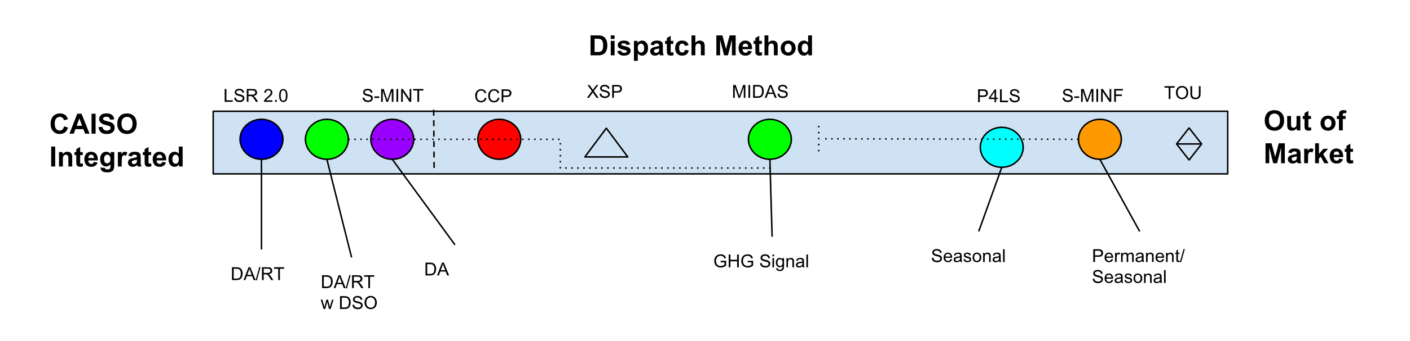

At the extreme ends of this spectrum are CAISO market integration and Out-of-market dispatch. LSR 2.0, a fully integrated product dispatched based on day-ahead or real-time market price signals, lies at the first extreme, along with a variation of MIDAS and the Market Integrated Distribution Service proposal, both which could participate in CAISO markets at the customer or aggregator’s discretion. These three products are designated as “market integrated.” Down the line from there lie the “market informed” products, beginning with CCP which is dispatched out of market, but based on daily day ahead market prices. MIDAS’ default proposal, to be dispatched based on a GHG signal continually derived from market data, sits in between the extremes. P4LS and the Distribution Load Shape product forecast market conditions and signal the desired Load Shift to the customer in advance through a targeted schedule. While P4LS updates that signal seasonally, Sunrun proposes a permanent schedule which reflects forecasted seasonal variations.

Can Out of Market Load Shift Impact Renewable Curtailment?

Market Informed Load Shift can indirectly affect market dispatch, and therefore renewable curtailment, even if it is not market dispatched. There are three paths for this impact:
- Long-Term: Long-term forecasts are based on historical metered consumption of electricity, adapting it to reflect potential changes in conditions (e.g., economic growth, rising temperatures). By extension, any persistent changes in load, whether they be the result of Load Shift or other demand-side activities, impact long-term forecasts and the resulting procurement decisions (e.g., Integrated Resource Planning).
- Day-Ahead: An LSE will use observed metered consumption (as well factors such as weather) to forecast its load in CAISO’s day ahead market. As an LSE’s load bid is one input to the CAISO’s forecast, observed consumption will impact which supply resources receive a market award.
- Real-time: The real-time market adjusts to any discrepancies in forecasted load as compared to demand. Any non-market load shift that can dynamically respond to CAISO forecasts will be able to mitigate curtailment. However, a risk with an out of market approach is that if it is not dynamic, meaning it cannot change output in response to an updated CAISO forecast, it may actually result in a more inefficient market. For example, if a load shift resource responds to negative prices (as a proxy for oversupply) by increasing load, but updated forecasts results in positive prices, the increase in load may turn on generators and could do more harm than if it did not operate or was market integrated.

Non-market integrated load shift can impact the wholesale market based on the:
- magnitude of the load change – is it enough to rise above noise in load data?
- consistency of the load change – is it predictable enough for a forecast to anticipate the change?
- implementation by the forecaster – does the LSE effectively represent the change in its forecast?
- granularity of the resource – is the response in a location where it can impact local curtailment? If it is dispatchable, can the resource respond in sync with the market’s curtailment determinations (15 and 5-minute intervals).

In sum, a resource which is larger, more consistent, effectively handled by the forecaster, and available at the time and place needed will have a greater impact on renewable curtailment. One which is less so, will have less of an impact. A challenge in developing Load Shift is how to maximize this impact without introducing requirements which prevent the participation of customers.

The CAISO maintains ancillary service reserves specific to both system and local regions in response to changes in real-time.

There are several reasons to consider dispatch method a key differentiator. First, current Commission policy requires a demand response resource be market integrated or incorporated in the CEC’s Long-Term Load Forecast to be eligible for resource adequacy value. Without a change to that policy or improvements in the reflection of Shift in forecasts, all market informed products would presumably be ineligible for a resource adequacy designation, which has traditionally been vital for DR business models. Second, by increasing demand during periods of low net load and decreasing it during periods of scarcity, Load Shift stands to increase market efficiency. The more direct the resource’s participation in the market, the more direct the impact and coordination between resources. Third, participant access to market revenues earned through market participation increases the competitiveness of those resources. Fourth, the value for the service is transparently provided by the market. Finally, market dispatch can enable easier tracking of the resource’s GHG impact because of the strong correlation between market prices and the carbon intensity of power supplied through the CAISO market.

But these advantages to market integration may be offset by drawbacks. Proponents of the Market Informed approaches cited the cost and complexity of market participation as a primary hindrance. (These challenges are well documented and currently being addressed in the Supply Side LSWG for Demand Response, so they are not repeated here). With lower transaction costs, market informed approaches could increase the reach of Shift to customer loads and classes that are not market integrated. The P4LS product, which is akin to an opt-in Time of Use rate that gets updated seasonally, may offer a single customer a chance to participate with considerably less complexity than, for example, PDR-LSR which requires an investment in storage, alters the customer’s price signal every 15 minutes, requires aggregation, and implies greater performance risk.

Dispatch Locational Granularity
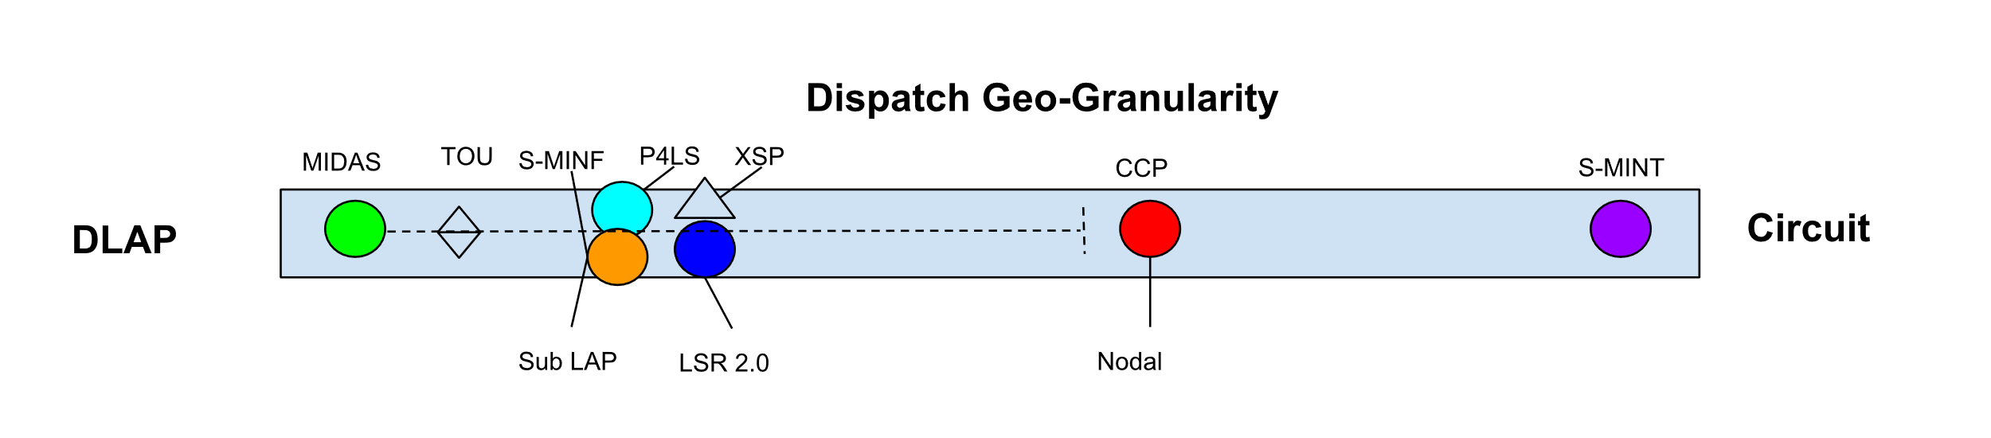
At the extreme ends of this spectrum are a CAISO Default Load Aggregation Point and a distribution circuit. These extremes warrant some emphasis as the difference between both ends is quite substantial. Whereas they may only be one circuit per Pnode, there could be tens of thousands of circuits across a Default Load Aggregation Point. In between the extremes lie sub-load aggregation points and Pnodes.

The least granular dispatch proposed would be MIDAS based on a GHG signal derived from analysis of generation across a Default Load Aggregation Point. Moving right along the spectrum lies a cluster of proposals that would dispatch at the sub-lap level, including Distribution Load Shape, LSR 2.0 and P4LS. Further downstream sits CCP, dispatching at the Pnode and Market Integrated Distribution Service which envisions active dispatch by a Distribution System Operator at the circuit-level. A whisker stemming from MIDAS denotes that if the resource is aggregated and dispatched based on market prices (instead of GHG signals derived from system-wide facilities), more locational granularity could be achieved.

There are several reasons to consider locational granularity of dispatch a key differentiator. First, market price signals are obscured if/when they are a compilation or average of nodal prices, as is the case for all proposals except CCP and Market Integrated Distribution Service. This averaging can diminish the impact (and investment in) nodal prices, which provide greater fidelity, leading to increased market efficiency. Second, granular dispatch can solve more problems. For example, if there is a local oversupply event happening in a load pocket in the north due to transmission constraints and a load shift resource that is dispatchable or targeted on a system basis is located in the south, it cannot relieve the oversupply condition. In addition, the increase in load in the south could have the negative effect of turning on generation in the south to serve the new increase in generation in that area. Ideally, one would have a resource that is able to increase load at the same node where the price is negative. Third, providing local resource adequacy or distribution services will require corresponding targeted dispatch. To the extent those needs rise, so will the need for locationally sensitive dispatch. Underscoring this observation, PG&E’s XSP Pilot Report concludes, at scale, it will be “imperative” that Load Shift gets integrated with distribution planning and operations.

With these advantages to greater locational granularity noted, achieving this objective comes at a cost. First, this filter narrows and/or divides the pool of customers available to provide Load Shift. Second, any Load Shift requires grid operators have insight into grid conditions at the grid edge, the ability to communicate dispatch signals, and assurances the resource will respond when called. Gaining these capabilities has been the focus of the Commission’s efforts to develop distribution services markets and remains a work in progress.

Dispatch Temporal Granularity

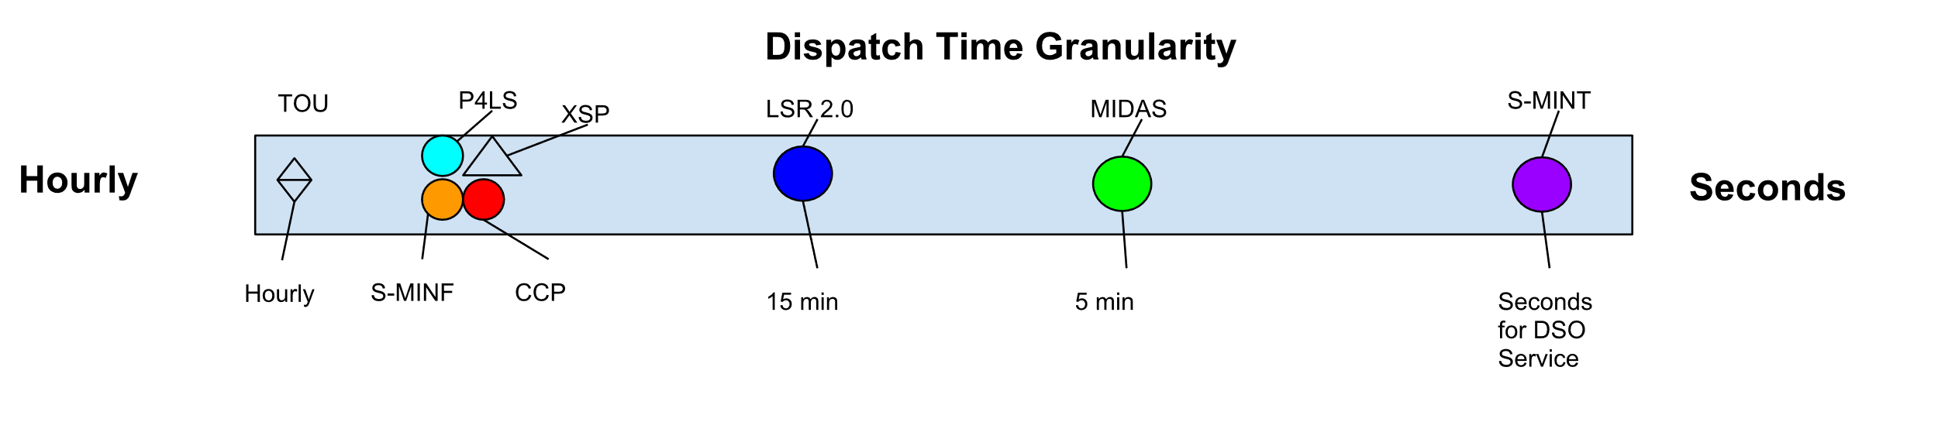
With regards to the temporal granularity of dispatch, the extremes are timescales of hours and seconds. As shown, a cluster of proposals would be available for control at hourly steps, including P4LS, Distribution Load Shape, and CCP. LSR 2.0 is available at 15-minute intervals for day-ahead and 5-minute intervals for real-time. The Market Integrated Distribution Service proposal would be available for dispatch at a more granular level (seconds) by distribution operators in service of distribution system needs.

There are several reasons to consider temporal granularity of dispatch a key differentiator. First, the ability to meet certain grid needs may depend on the dispatch time for the Load Shift: quicker responses enable more grid needs to be met. For example, CAISO markets clear at 15 and 5-minute increments, determining whether and how much renewable curtailment occurs. Alignment with those time increments provides for a more direct impact on renewable curtailment. Furthermore, resource adequacy and distribution services have defined response times. To be eligible to serve those needs, a Load Shift resource must have corresponding responsiveness.

These advantages noted, some customers may not be able to respond quickly or invest in technologies which would automate their response and provide the required telemetry to grid operator(s) who rely on the Load Shift. More temporally granular dispatch likely requires investment in automation technologies which has a cost: it would be a waste to require that investment unless the advantages clearly outweigh the costs.

Roles of IOU and Aggregators

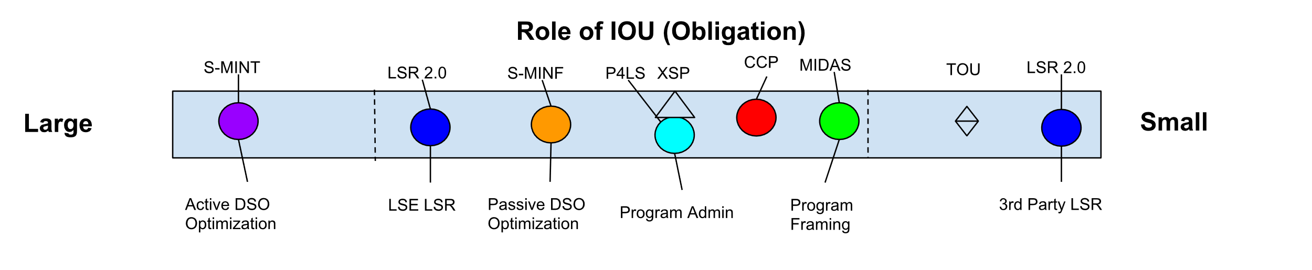
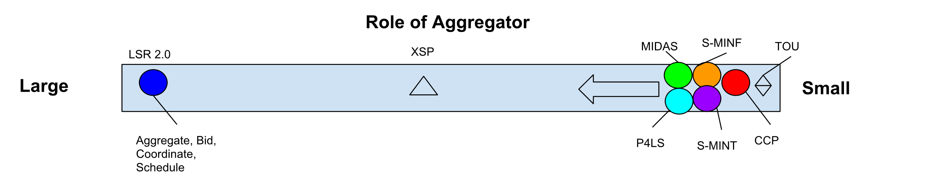

The six proposals anticipate a wide range of roles for Investor Owned Utilities (IOUs) and at least one key, potential difference in the role of the aggregator. The extremes are designated “large” and “small” to represent the relative complexity and involvement.

With regards to the role of the utility, the Market Integrated Distribution Service proposal anticipates the largest role for a utility, as it envisions the utility acting as a Distribution System Operator, actively optimizing the Load Shift across distribution and wholesale domains. None of the other proposals contemplates the utility optimizing across these domains; all of the other proposals envision the Load Shift is passively accommodated by the utility in its service as a distribution system operator.
Role of Community Choice Aggregation
The Working Group did not benefit from representatives familiar with the plans and interests of Community Choice Aggregators. Subsequent initiatives to develop demand response products would benefit from such perspective.

A second distinct category includes LSR 2.0 (IOU program), Distribution Load Shape, P4LS, CCP and MIDAS. In this category the utility serves as a program administrator, with decreasing degrees of involvement as you move from left to right along the spectrum. Distinct in this category is LSR 2.0 (third Party Aggregation), in which the utility plays a relatively passive role.

With regards to the role of the aggregator, the proposals initially fall at two extremes. LSR 2.0 requires a role for third party aggregators, other proposals do not. As detailed in the other non-LSR 2.0 proposals, a role for aggregators is possible and potentially beneficial (which is signified in the diagram by an arrow moving from right to left), but do not require third party aggregators.

Why does this matter? First, one of the Commission’s guiding principles speaks to its desired role for third parties: demand response shall be market-driven leading to a competitive, technology-neutral, open-market in California with a preference for services provided by third-parties… Examining the proposals relative to this principle suggests a tension that may require further discussion. Second, the success of Load Shift may depend on effective coordination between utilities, aggregators and customers. Third, the respective roles of utilities and aggregators impact how one would incentivize customers to take desired actions.
How does Load Shift fit into DRAM?
The Commission has developed the Demand Response Auction Mechanism to enable the exchange of resource adequacy from market integrated demand response providers and load serving entities. To the extent that Load Shift products will be offered by third party aggregators and meet grid needs beyond energy market participation, DRAM may be a suitable mechanism to facilitate that exchange. To accomplish this outcome, further consideration to the product definition and a corresponding contract mechanism would be warranted, with the understanding that the Commission was in the process of reviewing and evaluating the future of DRAM at the time this report was submitted.

Targeted Customer Class
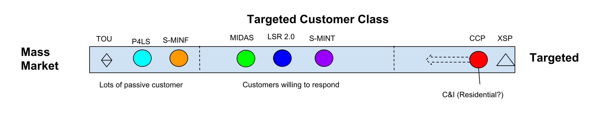
The proposals can also be differentiated by their envisioned reach from a few “targeted” customers to many “mass market” customers. Along this criteria, P4LS and the Distribution Load Shape proposal both intend to serve many customers, which is made possible in part by the assumption those customers will participate relatively passively. Like a Time of Use rate, these proposals provide customers an initial target schedule and an incentive to match their load to that schedule; with the exception of P4LS’s seasonal update, no further signaling to the customer is anticipated. In contrast, MIDAS, LSR 2.0, and the Market Integrated Distribution Service proposals would provide frequent signal(s) and depend on customer responses. Of note, LSR 2.0 is able to aggregate price responsive load, while MIDAS is able to be used for either price responsive or environmentally driven load. Finally, whereas all the other proposals are envisioned to be open to all customers, CCP would be focused on large Commercial & Industrial customers (only).

To reach the full potential of Load Shift in California estimated by LBNL, a broad strategy may be needed. While LBNL’s study estimates most Load Shift capabilities are from the commercial and industrial sectors, residential customers may also make meaningful contributions. The proposals herein offer points of entry to a range of customer classes and types. The LSWG regards this diversity as one of the key strengths of the proposals.

Regulatory Readiness
Recognizing time and resources are limited, the LSWG considered the regulatory hurdles of each product as an additional data point when comparing the products. There are barriers to regulatory readiness that are shared by all six of the proposals. These shared challenges are identified below as a part of the LSWG’s recommendations for “next steps.” Beyond these shared challenges, there are barriers that are specific to some product proposals. They are as follows:

LSR 2.0 | CCP | MIDAS | P4LS | Market Integrated Distribution Service | Distribution Load Shape
*Implementation of another phase of ESDER  * Equivalent new tariffs or contracts with the LSE | * Change of FERC – jurisdictional non-coincident demand charges (or mitigation)  * GRC Phase 2 to evolve into a new rate | * None, but there is additional value creation with more granular AMI data visibility | *Development of a new settlement and baseline methodology | * Development of new DR model for Dx Services  * New tariffs or contracts with the UDC  *Implementation of MUA rules (expected in 2019)  * All LSR 2.0 dependencies | *Development of load shapes by circuits (e.g., PG&E has 3,000+ distribution circuits)  * Development of new DR model for Dx Services  * New tariffs or contracts with the UDC  *Implementation of MUA rules (expected in 2019)

These barriers have varying degrees of difficulty: none are easy, none are insurmountable.

Considering Questions from the Ruling

Resource Adequacy
The Commission’s current Resource Adequacy construct recognizes the capacity value of load shed consistent with current resource adequacy requirements (i.e., Must Offer Obligations) but may not recognize the full value of Load Shift. The LSWG also considered the potential for Load Shift to make positive contributions toward raising minimum net load (which in turn reduces downward and upward ramping “flexible capacity” needs). Neither of these positive contributions would be eligible for direct resource adequacy credit under the current framework, although if such contributions are effectively reflected in load forecasts, their value would materialize. Given these circumstances, the LSWG considered whether changes to the current resource adequacy construct may be warranted to allow providers of Load Shift additional incentives.

The LSWG proposes the following suggestion for further consideration in the resource adequacy context:
- As a threshold matter, current resource adequacy rules require that any service of flexible resource adequacy must be bundled with service of system/local resource adequacy. A Load Shift provider cannot have a contract with an LSE to provide flexible resource adequacy without also obligating that resource to be available during a system/local peak. This requirement limits the demand response resources available to serve ramping needs, as some of resources may be available to serve the ramp, but not willing to commit to also serving the peak. Further consideration of whether the justifications for this rule outweigh the resulting negative impact on demand response resources is warranted.
- Load Shift can increase demand during the downward ramp, thereby reducing the need for generators to be taken offline or curtailed during that period. Whether and to what extent this contribution creates resource adequacy value warrants further consideration.
- Load Shift can raise minimum load thereby reducing the need for downward and upward flexible resource adequacy. Whether and to what extent this contribution warrants a resource adequacy value warrants further consideration.
The LSWG recognized that any determination of resource adequacy value may introduce performance requirements (e.g., telemetry, response time, response duration) on the providers of Load Shift. Those performance requirements may vary by the resource adequacy service being provided. Discussion of the appropriate performance requirements should be considered alongside the positive contributions identified above.

The LSWG considered whether resource adequacy payments are necessary to incentivize customer and/or aggregator participation in the development of Load Shift. The LSWG concludes that, if in considering the questions raised here, the Commission finds Load Shift provides a reliability service, commensurate resource adequacy capacity payments would be appropriate; however, if the resource does not provide reliability services, capacity payments should not be used to incent Load Shift. In that circumstance, other incentive instruments would be more appropriate.

Data Access
The LSWG considered whether there were any data access issues, which must be addressed to support the development of Load Shift in California. The LSWG concludes that Rule 24/32, as well as ongoing efforts under the Distribution Resource Planning proceeding (R.14-08-013) and the new applications filed by each utility to expand click-through (proceeding pending), should provide an adequate foundation for addressing most data access issues related to Load Shift. The LSWG recommends that the Commission make clear that providers of Load Shift are eligible to access data under Rule 24/32 and Distribution Resource Planning, consistent with the rules applied to any of the entities.

Beyond that foundation, the LSWG notes that several proposals require access to price or GHG signals, price information from the wholesale markets, or distribution grid condition data. In the event those proposals are further pursued, the pilot or program development process should detail how the provider would access the necessary data.

Greenhouse Gas Emissions
Per the direction of D.18-06-012, GHG emission impacts were considered for each proposal and included in the product descriptions. As a threshold matter, the LSWG adopted two guidelines for its approach to complying with this direct. First, while the Commission’s direction was specific to storage the LSWG decided to consider GHG impacts of Load Shift from all technologies. This guideline was considered consistent with the LSWG’s commitment to technological neutrality. Second, the LSWG interpreted the direction to consider GHG impacts of Load Shift generally, but not to resolve the question with finality.

Following these guidelines, the emissions impacts of Load Shift were evaluated on two criteria. First, if the proposal was market integrated and/or resulted in incremental consumption during periods of negative pricing, that proposal would not require additional emissions metrics due to the strong correlation between negative prices and GHG emissions in CAISO markets. Second, If the proposal was not market integrated or was reasonably expected to result in consumption during periods of positive prices, that proposal would need to identify its proposed emission metric for further consideration by the Commission. Detailed proposals for how these emission metrics would work could be considered at the request of the Commission, but need not be delineated at this time and would be best addressed in coordination with comparable determinations being considered in the Self Generation Incentive Program.

To further consideration of Load Shift, the LSWG saw fit to develop and consider a first order analysis of the GHG impacts from Load Shift. This analysis was not intended to provide a definitive assessment or to be specific to individual resources. Rather, the analysis provides high-level assurance that a diverse portfolio of Load Shift resources will, on average, reduce GHG emissions. From this preliminary assessment, the LSWG draws the following hypotheses:

- Broadly, Load Shift stands to significantly reduce GHG emission by reducing renewable curtailment.
- Were Load Shift mature in 2017, approximately 50% of the operational curtailment may have been avoided by a shift of 1% of retail load.
- Both market integrated and market informed Load Shift can be impactful. The market integrated approach results in a more direct positive impact on curtailment; while the market informed approach has the advantage of also providing greater peak load reduction and energy market cost savings.

One aspect of the GHG Emissions impact issue which may warrant further consideration: is it necessary for every resource providing Load Shift to reduce GHG emissions or is it only necessary that the whole of California’s Load Shift resource reduces emissions? The Commission’s disposition on this question could impact key aspects of these proposals advanced herein, including how the GHG impact of each would be assessed. Therefore, further guidance from the Commission is requested. Stakeholders are prepared to support such inquiries as the Commission’s consideration of Load Shift develops.

Coordination with CAISO
The LSWG completed the task of considering closer coordination with CAISO by developing a product proposal (LSR 2.0) which is fully CAISO market integrated and evaluating the advantages and disadvantages of that integration. If the market informed proposals proffered herein reached scale, new challenges and opportunities for coordination with CAISO would emerge. CAISO also recognized the value of market informed products ability to meet the goals of Load Shift.

The CAISO proffered substantial contributions to all product proposals and anticipates ongoing collaboration with stakeholders and the Commission in the forthcoming rulemaking on new models of demand response.
Is Load Shift Urgent?
Factors impacting the urgency of Load Shift include:
- The magnitude of renewable curtailment and cost of backfilling that curtailment in order to reach SB100’s targets;
- The magnitude of ramping requirements and costs of serving them;
- The potential for dramatic increases in electrification load, from both transportation and buildings; and
- The time it takes to transform customer energy usage patterns.
The Working Group considers each of these factors as positive contributors to the urgency of developing a meaningful Load Shift capability for California.

Recommendations
Based on all of the above, the LSWG makes the following recommendations for Commission consideration.

- The Commission should bring new focus and energy to developing Load Shift.
- The Commission’s engagement with Load Shift should be actively coordinated with related efforts underway at the California Energy Commission and CAISO, as well as related Commission proceedings.
- The Commission should continue with a period of experimentation that will ensure adequate and proactive testing of policies, incentives and business models. The aim should begin by inviting pilot proposals along the lines of the products envisioned here in early 2019 with progressive maturation of load shift by 2025.
- The Commission should consider how to incentivize Load Shift and ensure incentives are consistent with the value the resource creates, including the avoidance of renewable curtailment and other grid services identified in the “Introduction” to this Report. With regards to the value of Load Shift, several questions warrant further consideration:
  - How should the Commission recognize the value of avoided renewable curtailment? Should such value be monetizable as an incentive for Load Shift, such as avoided RPS?
  - Load Shift allows California customers to benefit from negative- and low-priced energy, rather than exporting that benefit through regional exchanges. How should this value be reflected in the Commission valuation of Load Shift?
  - How should the impacts of Load Shift on distribution system operations and planning, which can be both positive and negative, impact the value of Load Shift? How should the products be coordinated and managed to mitigate distribution risk?

- Beyond the recommendations made above on Resource Adequacy, Data Access, GHG and Emissions, the following regulatory issues impact all proposed Load Shift products considered by this LSWG and resolution in some of these areas may be needed prior to implementing a load shift product:
  - Coordination with Retail Rate Design: Increasing energy consumed (take) increases a customer’s volumetric retail consumption charges during certain periods and may increase its demand charges. Reaching the full potential of Load Shift will require additional consideration of retail rate design.
  - Incrementality with providing other services: A resource value stacking Load Shift with any other service will be dependent on the outcomes of proceedings at the CPUC related to value for distribution services (DRP, IDER, DER Tariff Request) and any updates to the Commission’s adopted Multiple-Use Application rules. Where the Multi-Use Application conversation is taken up next and whether it will expand beyond energy storage are open questions.
  - Dual Participation rules were developed in light of load curtailment and will require an update in light of the bi-directional nature of Load Shift. No active proceeding is discussing dual participation in light of bi-directional DR, but since dual participation rules can be logically considered a subset of broader MUA rules, rules for dual participation with load shift may be most appropriate in a successor MUA proceeding.
  - Performance Evaluation: For any DR that uses a baseline (not just for load increase), baselines will need to be evaluated and potentially updated in light of more frequent dispatch, device participation, bi-directional operation, and export. No active proceeding addresses this issue.
  - Implementation Costs will vary and are dependent on a final design of each product.
  - CEC Demand Forecast will need to incorporate the demand-side changes associated with any non-market-integrated products.
  - Role of utility and third-party aggregator: The design and implementation of a load shift product may vary as either the utility or the third-party aggregator take on a greater or smaller role.

Appendices

Appendix A:

Product evaluations available here

Appendix B:

Stakeholder List:
Advanced Microgrid Solutions | Energy Innovation | Sacramento Municipal Utility District
Brattle Group | EnergyHub | San Diego Gas & Electric Company
C Power | Energy-Solution | SCD Energy Solutions
California Efficiency and Demand Management Council | Enernoc | SCD Energy Solutions
California Energy Storage Association | Engie | Schatz Energy Research Center
California Institute for Energy and the Environment | Entergy | Smarter Grid Solutions
California ISO | Evolve Energy | Sonnen Batterie
California Large Energy Consumers Association | Gridworks | Southern California Edison
California Large Energy Consumers Association | Just Energy | Stanford Linear Accelerator Center
California Public Utilities Commission | Lawrence Berkeley National Laboratory | Stategy Integration
California Solar and Storage Association | Natural Resources Defense Council | Steffes
California Solar Energy Industries Association | Nest | Stem
California Energy Commission | Nest Labs | Strategen
Center for Sustainable Energy | NRG Curtailment Solutions | Sunrun
Clean Coalition | Ohmconnect | Tesla
Community Choice Partners | Olivine | The Union of Concerned Scientists
Con Edison | OpenEE | THEnergy
E3 | OPower | UMining
Ecco International | Pacific Gas & Electric Company | Union of Concerned Scientists
Energy Center | Pika Energy | Watt Time
Energy Centre | Public Advocates Office | Willdan Corporation

“Tracking Progress - Renewable Overview” California Energy Commission. June, 2018. https://www.energy.ca.gov/renewables/tracking_progress/documents/renewable.pdf
“2017 Report on Market Issues & Performance.” CAISO. June 2018. http://www.caiso.com/Documents/2017AnnualReportonMarketIssuesandPerformance.pdf
“Managing Oversupply.” CAISO. October, 2018. http://www.caiso.com/informed/Pages/ManagingOversupply.aspx.
“Shift Demand Response: A Primer.” Lawrence Berkeley National Laboratory and Schatz Energy Research Center – Humboldt State University. February, 2018. https://gridworks.org/wp-content/uploads/2018/02/Shift-Demand-Response-Primer_Final_180227.pdf
Presentation to the Load Shift Working Group by CPUC and E3 Slide 16. April 2018. https://gridworks.org/wp-content/uploads/2018/04/04.18.18-Load-Shift-Working-Group-workshop-3_final.pdf
D.18-06-012, Page 78. CPUC.
D. 16-09-056, Page 47. CPUC.
These proposals are concepts which would need further detail before implementation. Many of the products were conceptualized to include a variety of options, leaving determinations about which options are most desired for subsequent evaluation. If the Commission chooses to operationalize these proposals as policies, programs or pilots, stakeholders will need to refine the proposals to provide necessary detail.
ESDER Stakeholder Initiative. CAISO. https://www.caiso.com/informed/Pages/StakeholderProcesses/EnergyStorage_DistributedEnergyResources.aspx
These deviations from PDR-LSR would require consideration through a CAISO stakeholder process, approval by CAISO’s Bord of Governores, and subsequent FERC approval.
Sub-Load Aggregation Points (Sub-LAPs): A CAISO defined subset of PNodes within a Default Load Aggregation Point (DLAP). CAISO has defined 23 Sub-LAPs, which are geographic areas that divide the electric grid. PG&E’s service territory is divided into 16 Sub-LAPs; SCE’s service territory is divided into 6 Sub-LAPs; and SDG&E’s service territory consists of one Sub-LAP. SubLAPs are the common unit at which day ahead load forecasting is done, and affect how loads can be aggregated into market bids. Proxy Demand Response is dispatched at the resource level and settled at the Aggregated-Pnode (APnode) level.
A full discussion of resource adequacy value can be found on page 23.
A contract for differences is an arrangement between a buyer and seller to share gains or losses incurred if the actual market price deviates from a forecasted, agreed upon price.
This approach is similar to what is being looked at in PG&E’s current Supply Side II DR pilot (SSP II) and DERMS pilot.
D.15-11-042, CPUC.
“Distributed Energy Resources Integration: Summaries and Opportunities” Olivine. January, 2014 & “Load Modifying Resource Demand Response Operations Working Group Compliance Report” Clean Coalition. May, 2015.
“Excess Supply DR Pilot 2015-2017 Summary and Findings”. Olivine and PG&E. August, 2018.
R.14-08-013 (Distribution Resource Planning) CPUC and R.14-10-003 (Integration of Distributed Energy Resources) CPUC.
In this context a utility may have responsibilities as both a Load Serving Entity and Utility Distribution Company. A detailed delineation is not provided herein, but highlight implications of this difference are noted.
Key parts of the current Resource Adequacy framework are under active consideration in R. 17-09-029 and the CAISO’s Resource Adequacy Enhancements stakeholder initiative. The LSWG’s recommendations are up to date as of December 2018.
Presentation to the Load Shift Working Group by Peter Alstone. November 2018. https://gridworks.org/wp-content/uploads/2018/12/LSWG_GridImpacts_Brief_20181126.pdf
Related Commission proceedings include SGIP (R.12-11-005), Integration of Distributed Energy Resources (R.14-10-003), Distribution Resource Planning (R.14-08-013), Integrated Resource Planning (R.16-02-007)

