A Roadmap to Decarbonize California Buildings
January 7, 2019

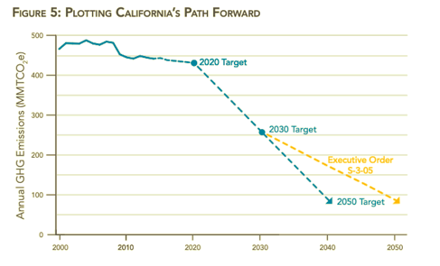
Introduction
Motivated to lead a global effort to mitigate the deepening climate crisis, California has adopted aggressive greenhouse gas emission reduction targets, including returning to 1990 levels by 2020, 40% below 1990 by 2030, and carbon neutrality by 2045.

Although California met its 2020 target early, the road ahead will be more challenging. A key part of that challenge will be decarbonizing buildings. Energy use within California buildings are responsible for more than 25% of statewide greenhouse gas emissions in 2016. To reach its overall carbon reduction targets, all California buildings must be fully decarbonized no later than 2045.
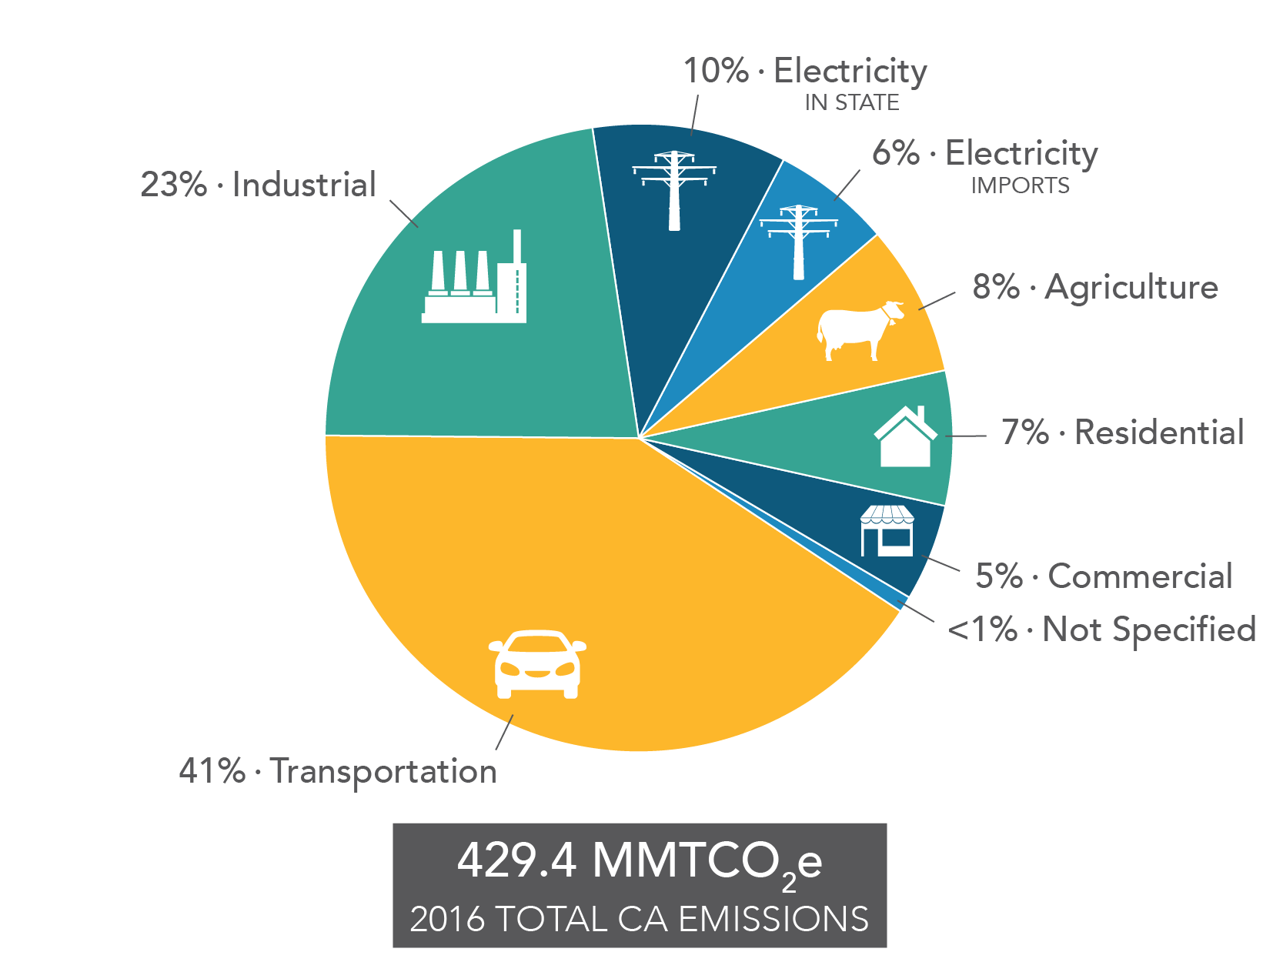
To decarbonize a building is to remove greenhouse gas emissions from the building’s energy use, achieved through making the building more efficient and integrating appliances powered by zero-emissions energy sources. Thanks to California’s proactive transition to carbon-free renewable energy, this can be achieved using technologies which are already available. Powered by renewable electricity, heat pumps can provide clean space and water heating, induction ranges can provide a superior and safe alternative in the kitchen, and efficient electric clothes dryers can avoid gas-powered dryers.

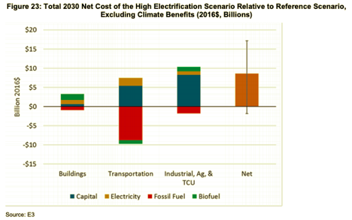
In addition to being technologically ready, each of these solutions can improve living conditions and save the state, building owners and occupants money. A recent analysis conducted by E3 for the California Energy Commission concludes the net cost of decarbonizing buildings is relatively small, even before accounting for health and environmental benefits.

While the technologies needed to decarbonize buildings are ready and the benefits of doing so are clear, the policy and market conditions are anything but. A range of barriers, detailed herein, are preventing California from reaching its potential. Addressing these barriers will require clear goals reflected in policy, cross-sector strategic investments and coordination, and leadership.

The Building Decarbonization Coalition was formed in 2018 to urge this action and support state and market leadership to decarbonize buildings. The Coalition consists of a diverse assembly of energy providers, public interest advocates, manufacturers, contractors, workers, builders, local governments, real estate interests and investors spanning California’s building community. Together this Coalition has the strength and diversity to create momentum, but reaching California’s goals will require leaders in state government, industry, and the public to adopt a shared path forward. Only when each entities incentives for action are aligned so they are rewarded for decarbonization will the State be able to achieve its goals.

This Roadmap shows that path forward, giving the great State of California a plan to assertively, efficiently, and equitably decarbonize all of California’s buildings. To propel California toward that goal, we call on the Governor to establish and lead a Building Decarbonization Interagency Task Force and direct the Task Force to:

- Reinforce the Targets and Goals of this Roadmap,
- Coordinate the Actions identified here,
- Provide the essential leadership needed to decarbonize California’s building sector.

Building Decarbonization Targets
In order to reduce carbon emissions from the building sector in line with California’s overall emission reduction goals, California can begin by adopting the following overarching target:
All California buildings must be fully decarbonized no later than 2045

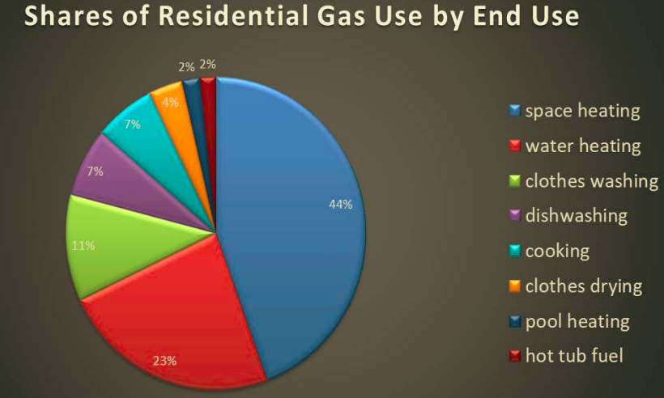
What does this target entail? In 2016, California’s buildings were responsible for directly emitting nearly 38 MMt of greenhouse gases. The residential sector contributed 24.2 MMt, the commercial sector 12.92. These emissions result primarily from space and water heating. Any new building construction between 2019 and 2045 which relies on fossil fuels for space and water heating represent incremental emissions, deepening the challenge.

Breaking the ultimate full decarbonization target into parts along these lines -- commercial/residential sector, new buildings/existing buildings, sources of emissions -- allows for more strategic targeting of actions, policy and investment.

New Buildings:
California can begin by harvesting its relatively low-hanging fruit through the adoption of Zero Emissions Building Codes at both the state and local level. A Zero Emissions Building Code requires buildings do not emit greenhouse gas emissions from on-site sources. Through these requirements, as grid energy increasingly gets cleaner and buildings add on-site renewable energy production, new buildings will begin to rely exclusively on clean energy. The following targets should be adopted:

Zero Emission Building Code will be adopted for the residential and commercial sectors by 2025 and 2028, respectively.

This target aims to accomplish three important threshold steps.

- Stop the bleeding: a third of California’s 2045 building stock will be built between now and then. New buildings which rely on fossil fuels for heat, hot water, cooking or drying clothes undermine its carbon emissions goals.
- Save money: Decarbonized, all-electric buildings cost less to build to code than those requiring additional gas infrastructure.
- Seed the market for retrofitting existing buildings: Zero Emissions Building Standards send a clear signal to critical industry stakeholders, including manufacturers, architects, real estate agents, builders and contractors: zero emissions buildings are worthy of your valuable time, attention and capital -- begin investing in building decarbonization now.

This target recognizes adoption and implementation of Zero Emission Building Codes in the commercial sector will be a greater challenge than the residential sector. By sequencing them with adoption of residential codes in 2025 followed by commercial codes in 2028, insights and momentum can be carried forward, easing the challenge of the commercial sector.

Existing Buildings
The key sources of emissions within existing buildings are space and water heaters. These are appliances which typically last between 8 and 20 years, providing scarce opportunities to impact whether a customer chooses a like-for-like fossil fueled replacement or a zero emission alternative. A progressive approach to replacing these appliances with zero emission alternatives over time will balance the need for progress with the languid speed of appliance turnover. The following targets strike this balance while achieving California’s goals:

% GHG reduction below 1990 levels from the overall building stock
2025: 20% GHG reductions from building sector
2030: 40% GHG reductions from building sector
2045: 100% GHG reductions from building sector

Equally important to reducing emissions from the building sector is ensuring that the buildings are efficient at retaining conditioned air and preventing air infiltration. These challenges are addressed by existing California energy efficiency targets. This Roadmap underscores those targets, but does not repeat them.

Market Share Targets for Underlying Technologies
Reaching the recommended targets in new and existing building implies the underlying technologies achieve progressively greater market share over time. In its analysis for the California Energy Commission, E3 concludes, “to decarbonize heating demands in buildings through a transition to electric heat pumps, without requiring early retirements of functional equipment, this transition must start by 2020 and achieve significant market share by 2030… new heat pump sales must represent no less than approximately 50% of new sales of HVAC and water heating equipment by 2030.”

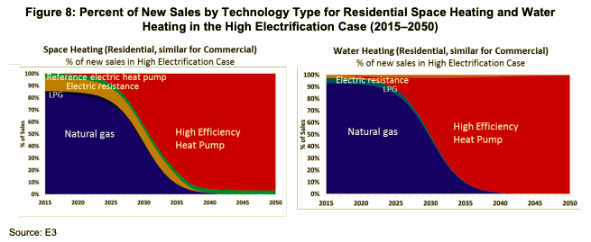

Informed by this analysis, California needs to embrace the following target market shares for underlying technologies:

Increase the share of high efficiency heat pumps for space heating from 5% of sales in 2018, to 50% in 2025 and 100 % in 2030.

Increase the share of high efficiency heat pumps for water heating from 1% of sales in 2018, to 50% in 2025 and 100 % in 2030.

These targets are grounded in E3’s analysis and recommendations, but accelerated by 5 years to reflect the imperative of full decarbonization by 2045.

In addition, the economics of decarbonizing California’s buildings depend heavily on one key factor: avoiding the cost of serving buildings with fossil fuels, especially natural gas. As such, while cooking, clothes drying, and fireplaces may make marginal contributions to overall emissions, electrification of these measures must be accomplished to achieve promised cost savings. The following target related to using electric induction stoves in the place of natural gas addresses this need.

Increase the share of high performance electric induction cooking from 1% of sales in 2018, to 50% in 2025, and 100% in 2030.

Overall, these targets reflect the need for dramatic, urgent increases in building decarbonization necessary to achieve California’s emission reduction targets.

In the following section, the Roadmap identifies some of the primary barriers to reaching these targets, followed by associated goals and principles to address those barriers.

Barriers, Goals and Principles of Decarbonization
Between California and its goals lie key barriers which must be overcome. These barriers include: low awareness and interest in building decarbonization measures, low perceived customer value, low perceived contractor and builder value, low availability, and misaligned policy.

Low Awareness and Interest | Currently there is a critical lack of awareness of and interest in decarbonized technology for residential and commercial buildings. Contributing factors include:  - lack of coordinated, focused, and sustained marketing effort  - lack of coordination among supportive organizations (e.g., policymakers, local governments, research institutions)  - Lack of coordination with similarly focused initiatives, like the California Solar Initiative or promotion of electric vehicle adoption.
Low Perceived Customer Value | Customers do not see a clear value proposition. Contributing factors include:  - Lack of incentives encouraging customer adoption  - Lack of financing solutions to help customers manage up-front costs  - Lack of coordination with existing building weatherization support programs  - Lack of paths to market for electric load shift enabled by heat pumps  - Lack of supportive electric rate designs
Low Perceived Contractor and Builder Value | Like customers, contractors and builders do not see a clear value proposition. Contributing factors include:  - Lack of incentives encouraging builders to construct carbon-free structures  - Lack of training for builders and contractors  - Lack of recognition for builders and contractors promoting building decarbonization  - Lack of coordination and support for local government permitting offices  - Lack of adequate measurement and valuation of GHG emissions
Low Availability | Building decarbonization solutions are not readily available. Contributing factors include:  - Lack of adequate electrical paneling at many homes and businesses  - Lack of relevant, supportive appliance standards  - Lack of coordination at a national-level necessary to induce increased manufacturing
Misaligned Policy | Existing policy and codes support an outdated view of the energy landscape in California that does not reflect existing GHG priorities. Contributing factors include:  - Lack of alignment between the state’s goals, policies, programs and metrics  - Lack of a plan for transitioning away from California’s legacy infrastructure  - Lack of support for local governments who would adopt reach codes

To reach California’s emission reduction targets, these barriers must be overcome. This Roadmap matches each of these barriers with a goal, thereby inverting a negative to a positive.

Goal 1: Customers, builders, contractors and policy-makers are aware of and interested in adopting building decarbonization measures.
Goal 2: Customers receive a good value from adopting building decarbonization measures.

Goal 3: Building decarbonization provides a better value to builders and contractors than fossil-fuel heating.
Goal 4: Supply-chains and delivery agents are able to meet rising demand for carbon-free building technologies with a quality product.

Goal 5: Policies are aligned to maximize customer awareness of and interest in building decarbonization, the customer, builder and contractor value proposition, and the industry’s ability to meet rising demand.

In achieving these goals, this Roadmap recognizes success requires more than just achieving the goal -- it matters very much how California achieves the goals. The following principles will guide how California’s goals are pursued.
Equitable: Deliver building decarbonization equitably to all communities to prevent disproportionately burdening customers least likely to be able to overcome the awareness and capital costs barriers.

Aligned: All stakeholder (customer, contractor, utility, agency, manufacturer) value propositions for building decarbonization must be recognized and aligned to achieve the speed and scale of transition California needs.

Grid Friendly: Ensure building decarbonization solutions serve as a benefit to the grid, especially the need to reliably integrate renewable energy into California’s power supply at least cost.

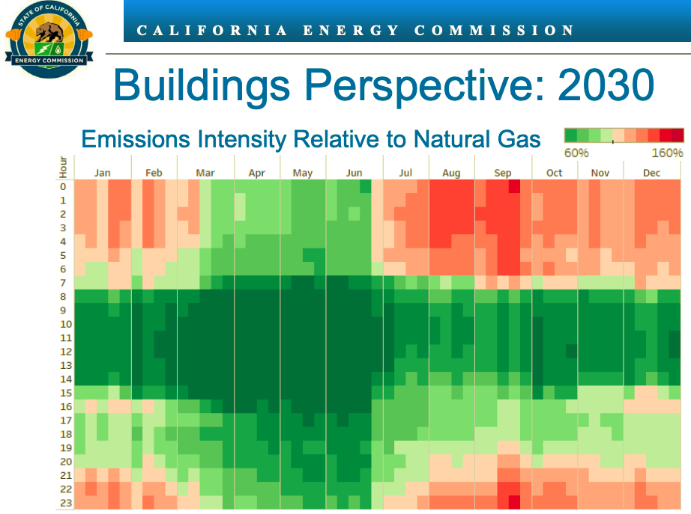
Grid friendly building decarbonization measures use electricity when the emission intensity of the energy are low (green) instead of when they are high (red).
Forward Thinking: Transform the building heating market through a forward-thinking, long-term commitments and incentives, avoiding the uncertainty and churn of start-stop programmatic cycles.
Data-driven: Proactively leverage targeted research and development initiatives to ensure the actions taken to decarbonize buildings are data-driven.
Innovative: Let California’s innovators design the business models to meet the need. Keep it simple and do not micromanage.

These principles -- equitable, aligned, grid friendly, forward-thinking, data-driven, and innovative -- will serve to ensure pursuit of building decarbonization avoids unnecessary pitfalls and is done with integrity.

Taking Action
California can begin pursuing the targets and goals identified here immediately. In this section we identify the specific actions needed to overcome each of the main barriers to building decarbonization and achieve the goals of this Roadmap.

Goal 1: Customers, builders, contractors and policy-makers are aware of and interested in adopting building decarbonization measures.
- Launch a marketing campaign to raise awareness and increase interest in building decarbonization.

- Launch induction cooktop campaign to educate consumers about benefits of induction cooking.
- Create a network of local governments and community based organizations to promote decarbonization, ensuring diversity in messaging and language.
- Build partnerships between solar, storage, and electric vehicle vendors and associations to promote co-benefits and form national partnerships where necessary.

Goal 2: Customers receive a good value from adopting building decarbonization measures.

- Create a strategic long-term (>=10 years) incentive program resulting in market transformation with sensitivity to customer bill impacts. Program design modeled after similar successful programs, especially the California Solar Initiative and Prop 39.

- Develop and launch low-cost, easily accessible financing options for building owners to access and contractors to sell. Where financing programs initially rely on public or ratepayer funds, a transition schedule toward private capital should be identified to allow for scale.
- Adopt all electric rates with appropriate baselines and other designs (e.g., opportunities to opt into real-time pricing) to ensure adoption and effective use of building decarbonization measures.
- Re-align low-income weatherization and efficiency programs to focus on GHG emissions, utility bill reductions, comfort and rapid deployment of measures through a comprehensive program of outreach, bulk purchasing, subsidized installation and contractor training.

- Accept and promote building decarbonization measures as grid integrated solutions to address and support grid needs through participation in demand management programs, such as the California Public Utilities Commission’s Load Shift Initiative, and distribution grid service solicitations and programs.

Goal 3: Building decarbonization provides a better value to builders and contractors than fossil-fuel heating.

- Produce midstream incentive programs for commercial and residential builders offering decarbonized new buildings and installers offering electric retrofits. Begin with expedited implementation of SB 1477.

- Support builders move to decarbonization through policies, programs, permitting and other solutions.

- Support contractors move to decarbonization through policies, programs, permitting and other solutions. Create and maintain a centralized resource for contractors to access information on best practices, technology, programs. Deploy a building electrification professional designation.

- Create a statewide program to voluntarily certify buildings and developments to recognize and promote builders and contractors supporting decarbonization.
- Launch a statewide campaign with local governments to expedite permitting and offer other incentives for building decarbonization measures.

Goal 4: Supply-chains and delivery agents are able to meet rising demand for carbon-free building technologies with a quality product.
- Offer a statewide electric panel upgrade program, developed in cooperation with efforts to promote electric vehicle adoption and strategically focused to provide greatest grid and ratepayer benefit.
- Develop an aggressive, national level campaign among policy makers to emphasize the need for massive increases in sales volumes for heat pump technology
- Produce industry-leading appliance standards for technologies to ensure quality, co-benefit achievement, durability and other desired factors. Reward products and manufacturers that meet the standards through bulk purchasing contracts through State procurement, incentives, recognition and other measurers.

Goal 5: Align Policy
- Align program and agency metrics focused on exculsivley reducing electricity consumption with metrics focused on reducing emissions, saving energy, promoting equity and benefiting the grid in state legislation and regulation, utility and CCA programs and local government activities.

- Support the opening of necessary CPUC proceedings to evaluate, design and potentially implement measures to provide a just and safe transition away from the natural gas system.

- Support local governments adopting building decarbonization policies.
These actions constitute a comprehensive approach to pursuing the targets and goals of this Roadmap. However, in many cases these actions are interdependent, demanding close coordination across a wide range of stakeholders. The following figure identifies stakeholders critical to the most urgent 11 actions of the Roadmap. 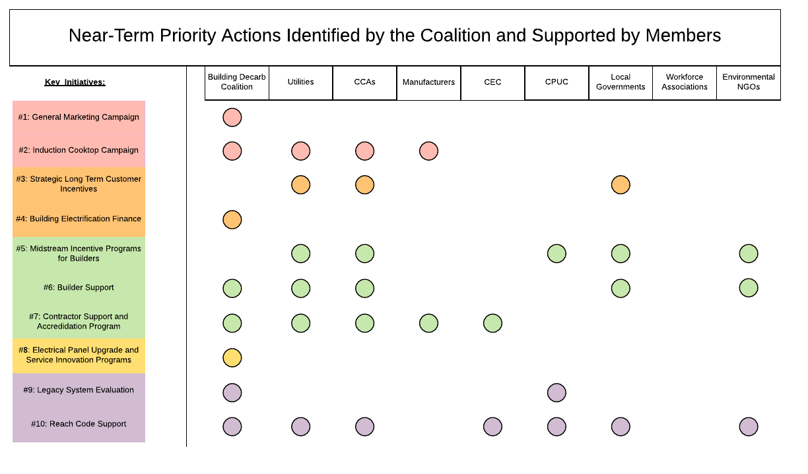

It is the the diversity of interests identified in this figure which underscores a key recommendation of this Roadmap: we call on the Governor to establish and lead a Building Decarbonization Interagency Task Force and direct the Task Force to:

- Reinforce the Targets and Goals of the Roadmap,
- Coordinate the Actions identified here,
- Provide the essential leadership needed to decarbonize California’s building sector.

Case Studies: California Tackles Big Problems
This Roadmap has identified targets, barriers, goals and actions needed to fully decarbonize California buildings by 2045. These are unabashedly ambitious targets and substantial challenges. But none of that is new to California, a state which has shown itself willing to tackle big problems over and over again. The following case studies show examples of California overcoming these same barriers, show that progress toward these targets and goals has already begun, and resinspire the leadership needed to implement this roadmap.

California Decarbonization Case Studies
The below are three cases of policy intervention that helped to address a significant barrier to enable decarbonization. These examples demonstrate that effective public policy can come in many shapes and sizes, and that a variety of stakeholders will need to coordinate in different ways in order to overcome often complex, inter-connected barriers to growth.
Barrier | Low Customer Value Proposition | Low Builder Contractor Value Proposition | Low Availability
Case Study | California Solar Initiative  10-year, $2 billion state program that offered incentives for solar installations on a per kW basis | City Ventures  home builders focused on low emissions housing development including townhomes, live/work lofts, condominiums, and detached single-family homes. | Electric Panel Upgrades for Electric Vehicles  IOUs are offering rebates for electric vehicle charging infrastructure, including electrical panel upgrades.
Action | Customers offered incentives to adopt solar pv based on the size of the installation or the performance of the system. Incentives were incrementally stepped-down as total MW of solar were installed in the state.  Net metering allowed customers to reduce their electric bills in line with the production of their system. | Three types of green home packages are available: all-inclusive green, solar all-electric, and solar + gas. All options are 15% more efficient than Title 24 requirements and feature products from partner vendors such as SunPower (solar PV), Nest (smart thermostats and home security), EnergyStar (appliances), Milgard (windows), and Kohler (faucets and showerheads) | SCE residential customers are reimbursed up to $1,500 for electrical panel upgrades, provided the work is performed by a certified electrician and the customer enrolls in a time of use rate. For commercial customers, IOUs offer reimbursements for customer-owned infrastructure (similar to SCE's residential program) and/or the IOU may pay for, install, own, and operate charging infrastructure.
Outcome | At the end of 2017, over 6,000 MW were installed at over 725,000 sites throughout California. | To date, XX green homes have been built and XX sold, including XX all-electric models. | About 370 projects are underway for over 4,600 charging ports across IOU territories. 35% of projects are in disadvantaged communities, 32% are multi-family dwellings and 60% are workplaces.

Conclusion
For California to meet its climate goals, homes and buildings must be decarbonized. This Roadmap provides two of the three key ingredients to a dedicated pursuit of that goal: a path forward and a coalition of the willing. The path forward calls for clear, ambitious targets and coordinated actions directed at key barriers to progress. The Building Carbonization Coalition, consisting of energy providers, public interest advocates, manufacturers, contractors, unions, builders, local governments, real estate interests and investors spanning California’s building community, stands ready to support the effort.

Together this Roadmap and Coalition has the strength and diversity to create momentum, but reaching California’s goals will require leaders in state government, industry, and the public to join in the effort. To gain that engagement California needs visionary leadership from Governor Newsom. Governor Newsom can help California and the world unlock a better way of life, and buildings hold the key.

Energy and Environmental Economics (E3), June 2018, Deep Decarbonization in a High Renewables Future, Prepared for the California Energy Commission, Available at: https://www.ethree.com/wp- content/uploads/2018/06/Deep_Decarbonization_in_a_High_Renewables_Future_CEC-500-2018-012- 1.pdf.
ibid
Includes associated methane, electricity generation, direct fuel combustion, and refrigerants. “2018 Update Integrated Energy Policy Report,” a presentation by CEC staff. June 2018.
California Air Resources Board, 2018, Greenhouse Gas Emission Inventory - Query Tool for years 2000 to 2016 (11th Edition), Available at: https://www.arb.ca.gov/app/ghg/2000_2016/ghg_sector.php. Includes distillates, kerosene, liquified petroleum gas, natural gas, and wood.
Rocky Mountain Institute. (2018). The Economics of Electrifying Buildings
Energy and Environmental Economics (E3), June 2018, Deep Decarbonization in a High Renewables Future, Prepared for the California Energy Commission,
Load Shift Working Group Initiative, https://gridworks.org/initiatives/load-shift-working-group/

